44th Austrian Chemistry Olympiad
National Competition

Theoretical Part
May 31st, 2018

Solutions

Problem 1 8 Points
Determining the Concentration of Lead(II) in 1950
1.1 Calculate the volume of hydrochloric acid necessary to reach pH=9.5. Neglect any possible influence of potassium cyanide and lead(II) ions for your calculation.
$9,50=9,25-lgx$ $x=\frac{n_{NH_{4}^{+}}}{n_{NH_{3}}}=0,5623$
$n_{NH_{4}^{+}}+n_{NH_{3}}=\frac{35∙0,35∙0,88}{17,04}∙\frac{75}{100}=0,4745 mol$
$\frac{n_{NH_{4}^{+}}}{{0,4745 - n}_{NH_{4}^{+}}}=0,5623$
$n_{NH_{4}^{+}}=\frac{0,4745∙0,5623}{1+0,5623}=0,171 mol$
$n_{HCl}=n_{NH_{4}^{+}}=0,171 mol$
$V_{HCl}=\frac{n_{HCl}}{c_{HCl}}=\frac{0,171 mol}{6 \frac{mol}{L}}=0,02846 L$ 3 bp

1.2 Give the pH value for which you expect substantial formation of hydrocyanic acid (i.e. at which the concentration of hydrocyanic acid exceeds that of cyanide ions) and under which the solution should not fall below.
9,40 1 bp

1.3 Calculate the maximum concentration of lead in a sample (in mol/L) that can be analyzed with this method.
$$m_{Dithizon}=0,00005∙7,5 mL∙1,594\frac{g}{mL}=5,98∙{10}^{-4} g$$
$$n_{Dithizon}=\frac{m_{Dithizon}}{M_{Dithizon}}=\frac{5,98∙{10}^{-4}g}{256,36\frac{g}{mol}}=2,33∙{10}^{-6} mol$$
$$n_{Pb^{2+}}^{max}=\frac{n_{Dithizon}}{2}=1,17∙{10}^{-6} mol$$
$c_{Pb^{2+}}^{max}=\frac{n_{Pb^{2+}}^{max}}{0,01L}=1,17∙{10}^{-4} mol/L$ 3 bp

1.4 Calculate the lead concentration of a sample for an absorbance of A=0.328 measured in a cuvette of 1cm path length. Assume complete complexation and extraction.
$$c_{Pb{\left(HDz\right)}_{2}}=\frac{A}{ε∙d}=\frac{0,328}{66450∙1}= 4,936∙{10}^{-6} mol/L$$
$$n_{Pb{\left(HDz\right)}_{2}}=c_{Pb{\left(HDz\right)}_{2}}∙V_{Tetra}= 4,936∙{10}^{-6}\frac{mol}{L}∙0,025 L=1,234∙{10}^{-7}mol$$
$c_{Pb^{2+}}=\frac{n_{Pb{\left(HDz\right)}_{2}}}{0,01 L}=1,234∙{10}^{-5} mol/L$ 3 bp

1.5 Calculate the percentual amounts of the different lead-containing species at pH=9.5.
[Pb²⁺] = b [PbOH⁺] = b₁ [Pb(OH)₂] = b₂ [HPbO₂–] = b₃
(I) b + b₁ + b₂ + b₃ = c(Pb²⁺)_{ges}
(II) $\frac{b_{1}∙{10}^{-9,5}}{b}=3∙{10}^{-7}$ ⇒ b₁ = b∙949
(III) $\frac{b_{2}∙{\left({10}^{-9,5}\right)}^{2}}{b}=3∙{10}^{-18}$ ⇒ b₂ = b∙30,0
(IV) $\frac{{b_{3}∙\left({10}^{-9,5}\right)}^{3}}{b}=7∙{10}^{-29}$ ⇒ b₃ = b∙2,21

(Ia) b + b∙949 + b∙30,0 + b∙2,21 = c(Pb²⁺)_{ges}
b∙ 982,21 = c(Pb²⁺)_{ges}
Pb²⁺: $\frac{1}{982,21}∙100=0,10\%$
PbOH⁺: $\frac{949}{982,21}∙100=96,62\%$
Pb(OH)₂: $\frac{30}{982,21}∙100=3,05\%$
HPbO₂⁻: $\frac{2,21}{982,21}∙100=0,23\%$ 6 bp
1.6 Calculate the total concentration of all lead species in the aqueous phase after extracting with the abovementioned amount of dithizone in tetrachloromethane. Base your calculation on a sample that initially contained c=1.00∙10⁻⁶ mol/L Pb(II).
[Pb²⁺] = b [PbOH⁺] = b₁ [H₂DZ]_{org} = d [Pb(HDz)₂]_{org} = k₁
c(H₂Dz)_{ges}= $\frac{n_{Dithizon}}{V_{Tetrachlormethan}}=\frac{2,33∙{10}^{-6} mol}{0,025 L}=9,33∙{10}^{-5} mol/L$
c(Pb²⁺)_{ges} $=1∙{10}^{-6}∙\frac{10}{113,46}=8,81∙{10}^{-8}$ mol/L
c(H₂Dz)_{ges} ≫ c(Pb²⁺)_{ges} ⇒ d ≫ k₁
(I) d + 2k₁ = 9,33∙10⁻⁵ ⇒ d ≈ 9,33∙10⁻⁵
(II) $b+b_{1}+k_{1}∙\frac{0,025}{0,11346}=8,81∙{10}^{-8}$
(III) $\frac{b_{1}∙{10}^{-9,5}}{b}=3∙{10}^{-7}$ ⇒ b₁ = b∙949
(IV) $\frac{{k_{1}∙\left({10}^{-9,5}\right)}^{2}}{d^{2}∙b}$ = 5,60 ⇒ $k_{1}=b∙\frac{5,60∙{\left(9,33∙{10}^{-5}\right)}^{2}}{{\left({10}^{-9,5}\right)}^{2}}=b∙4,87∙{10}^{11}$

(IIa) b + b∙949 + $b∙4,87∙{10}^{11}∙\frac{0,025}{0,11346}$ = $8,81∙{10}^{-8}$
b = 8,21∙10⁻¹⁹ mol/L
b₁ = b∙949 = 7,79∙10⁻¹⁶ mol/L
b + b₁ = 7,80∙10⁻¹⁶ mol/L
$$k_{1}=8,21∙{10}^{-19}∙4,87∙{10}^{11}=4,00∙{10}^{-7}$$
d = 9,33∙10⁻⁵ – 2k₁= 9,247∙10⁻⁵ ≈ 9,33∙10⁻⁵
⇒ assumption correct! 9 bp
Problem 2 8 Points
Chromium and its Compounds: Electrochemistry & Kinetics
2.1 Give balanced equations for all electrode processes.
Cathode:
2 H₃O⁺ + 2 e⁻ → 2 H₂O + H₂ 0,5 bp
CrO₄²⁻ + 8 H⁺ + 6 e⁻ → Cr +4 H₂O 1 bp
Anode:
6 H₂O → 4 H₃O⁺ + 4 e⁻ + O₂ 0,5 bp

2.2 Calculate the current yield for the deposition of chromium on the cathode.
$$n\left(H_{2}\right)=\frac{p∙V}{R∙T}=\frac{1∙{10}^{5}Pa∙4,15 m^{3}}{8,314 J{mol}^{-1}K^{-1}∙298 K}≈167,5 mol$$
$$η=\frac{n∙z∙F}{I∙t}=\frac{167,5 mol∙2∙96485As{mol}^{-1}}{1500 A∙7h∙3600sh^{-1}}≈0,855⇒85,5\% H_{2}$$
1,5 bp

Current yield for chromium: $η=0,145$ => 14,5% 0,5 bp

2.3 Calculate the mass of chromium deposited.
$$n\left(Cr\right)=\frac{I∙t∙η}{z∙F}=\frac{1500 A∙7h∙3600sh^{-1}∙0,145}{6∙96485As{mol}^{-1}}≈9,5 mol$$
1,5 bp
Mass of chromium: $m=n∙M=9,5 mol∙52g{mol}^{-1}=492 g$ 0,5 bp

2.4 Calculate the volume of the gas having developed on the anode at standard conditions (25°C, 1.00 bar).
$n\left(O_{2}\right)=\frac{I∙t∙η}{z∙F}=\frac{1500 A∙7h∙3600sh^{-1}∙1}{4∙96485As{mol}^{-1}}≈97,9 mol$ 0,5 bp

$V\left(O_{2}\right)=\frac{n∙R∙T}{p}=\frac{97,9 mol∙8,314 J{mol}^{-1}K^{-1}∙298 K}{1∙{10}^{5}Pa}≈2,43 m^{3}$ 0,5 bp

2.5 Calculate the missing potentials x and y.
$x=\frac{6∙0,295-3∙\left(-0,741\right)-0,55-1,34}{1}=2,10$ V
$y=\frac{3∙(-0,741)-(-0,424)}{2}=-0,90$ V 2,5 bp

2.6 Demonstrate that Cr(IV) can disproportionate to Cr(III) and Cr(VI) via suitable calculation.
Cr(IV) disproportionates,
because $E^{O}\left(Cr\left(IV\right) | Cr\left(III\right)\right)=2,10$ > $E^{O}\left(Cr\left(VI\right) | Cr\left(IV\right)\right)=0,945$ 1 bp

$$E^{O}\left(Cr\left(VI\right) | Cr\left(IV\right)\right)=\frac{0,55+1,34}{2}=0,945$$

2.7 Calculate the equilibrium constant for this disproportioning reaction at 25°C.
$∆E^{O}=2,10-0,945=1,155$ V 0,5 bp
$∆G^{O}=-z∙F∙∆E^{O}=-R∙T∙lnK$
⇒ $lnK=\frac{2∙96485∙1,155}{8,314∙298}=89,96$ ⇒ $K=1,2∙{10}^{39}$ 1 bp

2.8 Does Cr(II) tend to disproportionate to Cr(III) and Cr(0)? Tick the correct box and give a reason for your choice based on the Frost diagram of the relevant species.
O yes, tends to disproportionate X no, does not tend to disproportionate

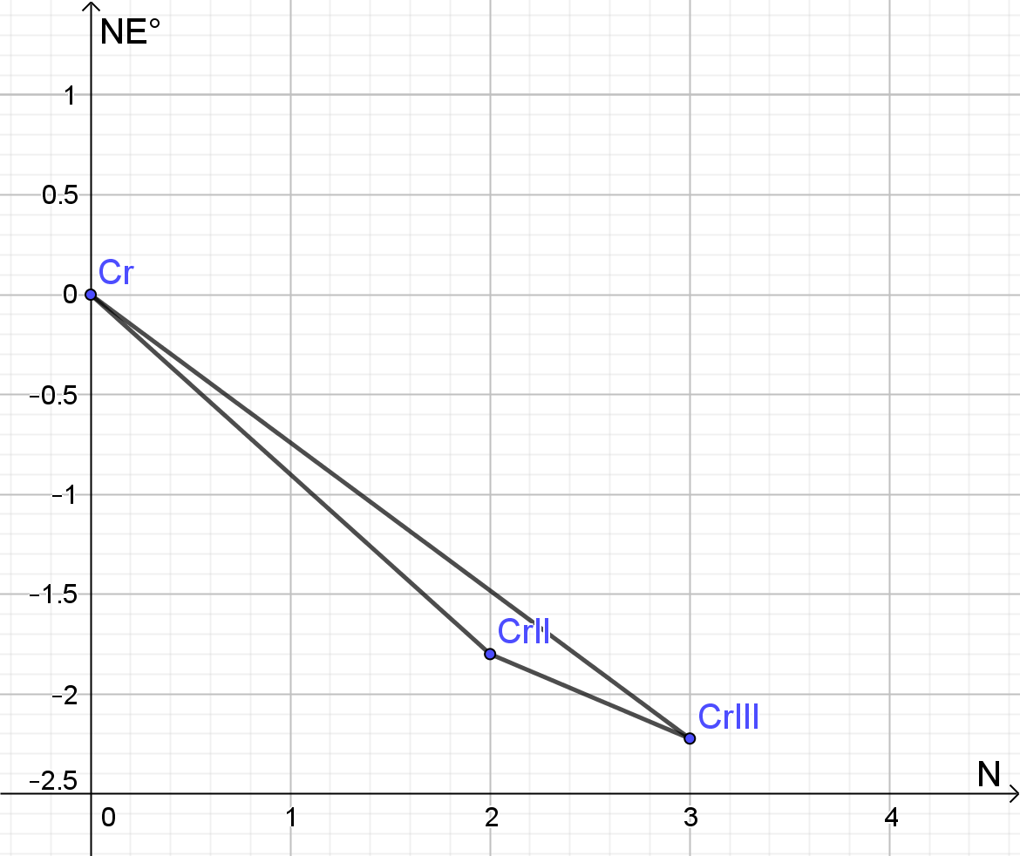 2 bp
Cr 0 V

Cr²⁺ -0,90 ⋅ 2 = -1,80 V

Cr³⁺ -0,741 ⋅ 3 = -2,223 V

2.9 Name two species showing pH-independent redox reaction in the diagram, at least within a certain pH-range.
all with horizontal separating line i.e.: Cr²⁺|Cr³⁺ 0,5 bp
2.10 Name two species showing protolysis that does not depend on pontential.
all with horizontal separating line i.e.: Cr₂O₇²⁻|CrO₄²⁻ 0,5 bp

2.11 In which pH range does Cr₂O₇²⁻ react to Cr³⁺?
0 to 4 0,5 bp

2.12 Formulate the half equation for the redox pair Cr₂O₇^{2–}| Cr³⁺.
Cr₂O₇²⁻ + 14 H⁺ + 6 e⁻ → 2 Cr³⁺ +7 H₂O 0,5 bp
2.13 Derive an equation E = f(pH) for the line between the two species Cr₂O₇²⁻ and Cr³⁺ at 298 K. (Assumption: the activities of the chromium species do not change).
Voltage change per pH-step:
$$E=E°+\frac{RT}{6F}ln\frac{\left[{Cr}_{2}{O_{7}}^{2-}\right]{[{H_{3}O}^{+}]}^{14}}{{[{Cr}^{3+}]}^{2}}$$
$$E=E°+\frac{RT}{6F}ln\frac{\left[{Cr}_{2}{O_{7}}^{2-}\right]}{{[{Cr}^{3+}]}^{2}}-\frac{RT}{6F}(-ln{\left[{H_{3}O}^{+}\right]}^{14})$$
and ${ln[{H_{3}O}^{+}]}^{14}=\frac{14log[{H_{3}O}^{+}]}{loge}=14∙2,3026⋅log[{H_{3}O}^{+}]$
$$E=E°-\frac{RT∙14∙2,3026}{6F}(-log\left[{H_{3}O}^{+}\right])$$
$$E=E°-\frac{RT∙14∙2,3026}{6F}pH$$
$$-\frac{RT∙14∙2,3026}{6F}=-\frac{8,314∙298∙14∙2,3026}{6∙96485}=-0,138 V$$
$E=E°-0,138pH$ 3,5 bp

2.14 Use this derived linear function to calculate E at pH=2.
$E_{2}=1,33-0,1380∙2=1,05 V$ 0,5 bp

2.15 Formulate a balanced equation for the reaction of HCrO₄⁻ with ethanol to Cr³⁺ und ethanoic acid.
HCrO₄⁻ + 7 H⁺ + 3 e⁻ → Cr³⁺ +4 H₂O |⋅4
CH₃CH₂OH + H₂O → CH₃COOH + 4 H⁺ + 4 e⁻ |⋅3
4 HCrO₄⁻ + 3 CH₃CH₂OH + 16 H⁺ → 4 Cr³⁺ + 3 CH₃COOH +13 H₂O
1,5 bp

2.16 As an example, calculate the concentration [HCrO₄⁻]_{t} for a titration volume
V(S₂O₃²⁻) = 10.3 mL.
$$n\left(S_{2}{O_{3}}^{2-}\right)=V\left(S_{2}{O_{3}}^{2-}\right)∙c\left(S_{2}{O_{3}}^{2-}\right)=10,3 mL∙0,02 mol L^{-1}=0,206 mmol$$
$n\left(I_{2}\right)=\frac{1}{2} n\left(S_{2}{O_{3}}^{2-}\right)$ und $n\left({{HCrO}_{4}}^{-}\right)=\frac{2}{3} n\left(I_{2}\right)=\frac{1}{3}n\left(S_{2}{O_{3}}^{2-}\right)=0,0687 mmol$
$$c\left({{HCrO}_{4}}^{-}\right)=\frac{n\left({{HCrO}_{4}}^{-}\right)}{V\left({{HCrO}_{4}}^{-}\right)}=\frac{0,0687}{10}=0,00687 mol L^{-1}$$
2 bp

2.17 Determine the reaction order x, by plotting concentration vs time in a suitable graph. Choose reasonable dimensions on each axis.
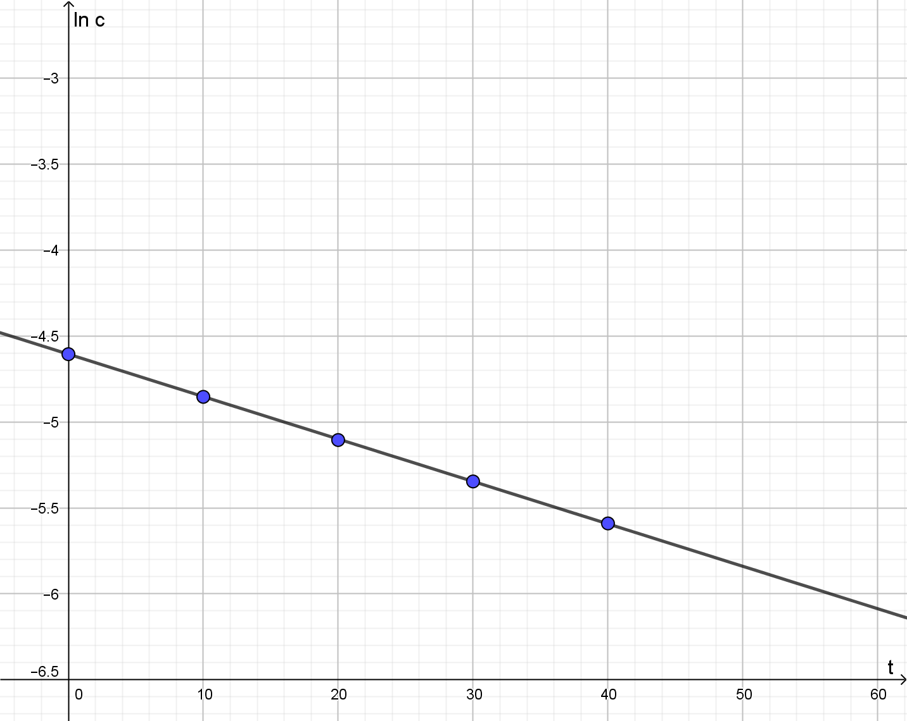 2 bp
A linear graph corresponds to first order kinetics. 0,5 bp
2.18 Calculate the rate constant k and give the result with correct units.
ln[HCrO₄⁻]_{t} = ln[HCrO₄⁻]₀ – k t
$k= \frac{ln\frac{{[{HCrO₄}^{-}]}_{0}}{{[{HCrO₄}^{-}]}_{t}}}{t}=\frac{ln\frac{0,01}{0,0078}}{10}=0,025 \min^{-1}$ 1,5 bp

Problem 3 17 Points
Organic Syntheses
3.1 Draw the configuration formulae of all possible stereo-isomers of lactide and determine the absolute configuration of each stereogenic center.
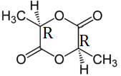 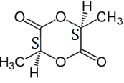 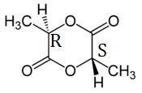 3 bp

3.2 Formulate mechanisms (including arrows for attacking species) for initiation (1), propagation (2, with n(LA) = 1) and termination (3) of the ring-opening polymerization of lactide (LA). Keep stereochemistry in mind!
Mark the repetitive unit in the product (after step 3) in the usual way.
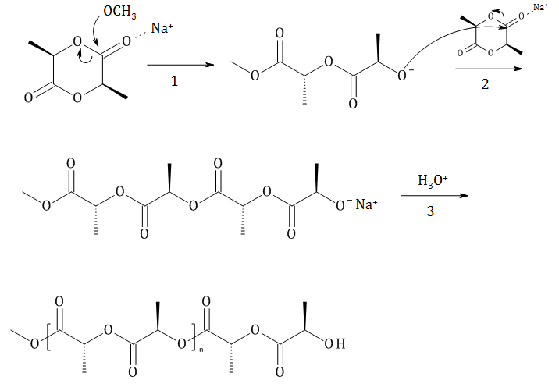 5 bp

3.3 Tick the correct answer
Polymerization leads to ….
 | a polyamide.
X | a polyester.
 | a polyanhydride.
 | a polycarbonic acid.
1 bp
3.4 Give the IUPAC-name/s of the product/s of acidic hydrolysis of lactide. Include stereodescriptors, if necessary.
(R)-2-Hydroxypropanoic acid 2 bp
3.5 Write down the formulae of F and F´.
C₉H₈O₄ 1 bp

3.6 Insert the structural formulae of A, B, D, E, E´, F, F´, G, H, I, and Z including correct stereochemistry into the boxes shown in the reaction scheme. In the same way add the empirical formulae of X and Y. Abbreviate possible benzyl-, phenyl- or MOM-residues as Bn, Ph or MOM. | 3.6 Zeichnen Sie unter Berücksichtigung der korrekten Stereochemie die Strukturformeln von A, B, D, E, E´, F, F´, G, H, I und Z sowie die Summenformeln von X und Y in die Kästchen im Reaktionsschema. Kürzen Sie allfällige Benzyl-, Phenyl- oder MOM-Gruppen mit Bn, Ph oder MOM ab.

3.7 Name the reaction mechanism for the reaction P(OBn)₃ + Z C (1st step).
S_{N}2 0,5 bp
3.8 Write down the stereochemical relation of E and E´ as well as F and F´.
diastereomeric / geometric isomers 1 bp
3.9 Formulate the reaction mechanism of the isomerization from F to F’ and suggest appropriate reaction conditions.
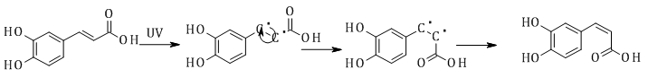
2,5 bp

3.10 What is the role of NaOEt in the first step when producing F from B and C? Draw the constitution formula of the reactive intermediate formed during this reaction. Name the reaction mechanism between this intermediate and the other reactand. How is this name reaction called?
base 0,5 bp
A_{N} 0,5 bp
HWE-Wittig 0,5 bp
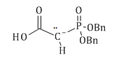 1 bp
3.11 Formulate a detailed reaction mechanism (use “R” for residues) for the formation of E and E´ from D and ethanal. Use arrows for attacking species. Name the reaction mechanism.
A_{N}
5 bp
3.12 Which is the underlying name reaction for the formation of D from A? Name the corresponding reaction mechanism.
Explain why this step is necessary within the reaction scheme.
Williamson ether synthesis 0,5 bp
S_{N}2 0,5 bp
protecting group; prevents oxidation of phenols 1 bp

3.13 Insert the structural formulae of A, B, C, D, F, G, H, I, L, M, N, O, P, and R into the boxes shown in the reaction scheme. In the same way add the empirical formulae of W, X, and Y. Several boxes already contain substructures of the respective compound, which you only need to complete. | 3.13 Zeichnen Sie die Strukturformeln von A, B, C, D, F, G, H, I, L, M, N, O, P und R sowie die Summenformeln von W, X und Y in die Kästchen im Reaktionsschema. Für manche der Substanzen sind schon Teilstrukturen angegeben, die Sie nur mehr ergänzen müssen.

3.14 Suggest reagents Z₁ and Z₂ for transforming I to K.
Z₁ = N₂H₄, H₂O₂, Cu²⁺
Z₂ = LDA 1,5 bp
3.15 Which name reaction is the basis of the step from H to I (cyclization)? Name the corresponding reaction mechanism.
Friedel–Crafts alkylation 1 bp
S_{E} 0,5 bp
3.16 Which type(s) of chirality are present in colchicine? Also state their number.
axial chirality and a stereogenic centre 1 bp

3.17 Give the stereodescriptor(s) of colchicine.
(aR)-, S- 2 bp

Problem 4 17 Points
Nitrogen and its Compounds
4.1 Label the schemes by writing the correct element symbols and molecular formulae into the respective boxes. Populate the schemes with electrons (arrows).

correct labelling 0,5 bp each; correct e-count 0,5 bp each, correct configuration 0,5 bp each
total max.: 4,5 bp

4.2 State magnetic behavior and bond order:
Nitrogen N₂  Bond order: ___ 3 ___ 0,5 bp  X diamagnetic 0,5 bp  ☐ paramagnetic | Sauerstoff O₂  bond order: ___ 2 ___ 0,5 bp  ☐ diamagnetic  X paramagnetic 0,5 bp

4.3 Calculate the overall quantity of heat Q₁ released during worldwide production of ammonia at isobaric conditions at 298 K in Joule.
M(NH₃) = 17,04 g/mol
180 mio tons = 1,80 ⋅ 10¹⁴ g correspond to 1,056 ⋅ 10¹³ mol 1 bp

Q₁ = 45,9 ⋅ 1,056 ⋅ 10¹³ = 4,85 ⋅ 10¹⁷ J 0,5 bp

4.4 Calculate the overall quantity of heat Q₂ released for one batch of ammonia in the bomb calorimeter at 298 K.
for ½ N2 + 3/2 H2 → NH₃ is ΔU = ΔH – ΔnRT therefore Δn = –1
ΔU = -45,9⋅10³ + 8,314 ⋅ 298 = -43,42 kJmol^{–1}
for 1,056 ⋅ 10¹³ mol are released Q₂ = 4,59⋅10¹⁷ J 2 bp
4.5 Calculate the sum mass of educts the death star needs to hold for one load of ammonia.
Retain of mass hence 180 million tons 1 bp
4.6 Calculate Kp for the formation of ammonia following equation R 4.1 at 298 K.
Δ_{R}S = –198,1 Jmol^{–1}K⁻¹ und Δ_{R}H = –91,8 kJmol^{–1}
Δ_{R}G = –91800 + 198,1 ⋅ 298 = -32766,2 Jmol^{–1}

K_{p} = exp(32766,2/(8,314 ⋅ 298) = 5,54⋅ 10⁵ 3 bp
4.7 Calculate Kp for ammonia formation at 400°C assuming that Δ_{R}H and Δ_{R}S have the same values as at 298 K.
$ln K_{673} = ln K_{298} - \frac{ΔH}{R}\left(\frac{1}{673} - \frac{1}{298}\right) = ln (554000) + \frac{91800}{8,314}\left(\frac{1}{673} - \frac{1}{298}\right)=-7,42$

K₆₇₃ = 5,99⋅10⁻⁴ 2 bp

4.8 Based on these values calculate Δ_{R}H₆₅₀ as accurately as possible.
use K₆₀₀ and K₇₀₀

$ΔH = \frac{ln K_{600} - ln K_{700}}{1/600 - 1/700}⋅R = -102,5$ kJ mol⁻¹ 2 bp

4.9 Calculate Cp of NH₃. Assume that the Cp values of H₂, N₂, and NH₃ are independent of temperature.
1 bp
1,5 bp
4.10 Caclulate E_{A} based on a suitable thermodynamic cycle.
thermodynamic cycle 2 bp
½ N2 + 3/2 H2 → N + 3 H E_{A}
N + 3 H → NH + 2 H Δ_{R}H = -314 kJ/mol
NH + 2 H → NH₂ + H Δ_{R}H = -389 kJ/mol
NH₂ + H → NH₃ Δ_{R}H = -460 kJ/mol
NH₃ → ½ N₂ + 3/2 H₂ Δ_{R}H = - Δ_{f}H = 45,9 kJ/mol
total: 0 → 0 0
E_{A} = 314 + 389 + 460 – 45,9 = 1117 kJ/mol 1,5 bp

4.11 Give the frequency of occurrence for the following molecules in %.
¹⁴N-¹⁴N: 99,634 % ⋅ 0,99634 = 99,269 % 0,5 bp
¹⁴N-¹⁵N: 2 ⋅ 99,634 % ⋅ 0,00366 = 0,7294 % 0,5 bp
¹⁵N-¹⁵N: 0,366 % ⋅ 0,00366 = 0,00134 % 0,5 bp
4.12 Calculate the reduced masses µ for each molecule below in amu and kg using five significant figures. Demonstrate the calculation in detail for one of them.
$μ =\frac{m_{1} m_{2}}{m_{1} + m_{2} }= \frac{14,0031 ⋅15,0001}{14,0031 + 15,0001} = 7,2422$ 0,5 bp
µ(¹⁴N-¹⁴N) = 7,0016 amu = 1,1630 ⋅ 10^{–26} kg 1 bp
µ(¹⁴N-¹⁵N) = 7,2422 amu = 1,2026 ⋅ 10^{–26} kg 1 bp
4.13 Calculate the force constant k of the N-N bond in gaseous nitrogen.
2 bp
4.14 Calculate the zero point energies E₀ of ¹⁴N-¹⁴N and ¹⁴N-¹⁵N in J.
¹⁴N-¹⁴N
$E_{0}=\frac{1 }{2}hν = \frac{1 }{2}hcν̃$ = 2,439⋅10⁻²⁰ J 1 bp
¹⁴N-¹⁵N
$E_{0}=\frac{1 }{2}ℏω = \frac{1 }{2}ℏ\sqrt{k/μ} = 0,5⋅1,055 ⋅{10}^{-34 }⋅\sqrt{(2489/1,2026⋅{10}^{-26})}$
$= 2,400⋅{10}^{-20}$ J 1,5 bp
4.15 Calculate the ratio of rate constants k₁₄₁₄/k₁₄₁₅ for bond breaking in ¹⁴N-¹⁴N and
¹⁴N-¹⁵N, respectively.
Calculation of energies in J /mol 1,5 bp
Arrhenius-equation: ln k = ln A – E_{A}/RT with E_{A} = $E^{‡}- E_{0}$ 2 bp
$ln \frac{k_{1414}}{k_{1415}}= \frac{1}{RT}(E_{0(1414)} –E_{0(1415)})⋅N_{A}$
$= \frac{1}{8,314 ⋅298}(2,439 -2,400) ⋅{10}^{-20}⋅6,022⋅{10}^{23}$
$= 0,0948$36
$\frac{k_{1414}}{k_{1415}} = 1,099$ 0,5 bp
4.16 The oscillation at … cm⁻¹ corresponds to situation (tick the correct one):
1500 cm⁻¹ | ☐ gas X α ☐ β ☐ γ 1 bp
2100 cm⁻¹ | ☐ gas ☐ α ☐ β X γ 1 bp
4.17 What is the activation energy of the catalyzed reaction?
4 kJ/mol 1 bp
4.18 What is the enthalpy of formation of NH_{3(ad)}?
– 95,9 kJ/mol 1 bp

4.19 State the rate law for the change in concentration of NH₃.
$-\frac{d[{NH}_{3}]}{dt}={k_{1}\left[{NH}_{3}\right]-k}_{-1}\left[{NH_{4}}^{+}\right]\left[{OH}^{-}\right]$ 1 bp
4.20 State a term for $\frac{dx}{dt}$, assuming that x denotes the momentary deviation from equilibrium concentration.
$$\left[{NH}_{3}\right]={\left[{NH}_{3}\right]}_{eq}-x, \left[{NH_{4}}^{+}\right]={\left[{NH_{4}}^{+}\right]}_{eq}+x ,\left[{OH}^{-}\right]={\left[{OH}^{-}\right]}_{eq}+x$$
$$\frac{dx}{dt}={k_{1}\left({\left[{NH}_{3}\right]}_{eq}-x\right)-k}_{-1}({\left[{NH_{4}}^{+}\right]}_{eq}+x)({\left[{OH}^{-}\right]}_{eq}+x)$$
$$\frac{dx}{dt}={-k}_{1}x-k_{-1}{\left[{NH_{4}}^{+}\right]}_{eq}x-k_{-1}{\left[{OH}^{-}\right]}_{eq}x+k_{1}{\left[{NH}_{3}\right]}_{eq}-k_{-1}{\left[{NH_{4}}^{+}\right]}_{eq}{\left[{OH}^{-}\right]}_{eq}-k_{-1}x^{2}$$
$$\frac{dx}{dt}={-\{k}_{1}+k_{-1}({\left[{NH_{4}}^{+}\right]}_{eq}+{\left[{OH}^{-}\right]}_{eq})\}x+k_{1}{\left[{NH}_{3}\right]}_{eq}-k_{-1}{\left[{NH_{4}}^{+}\right]}_{eq}{\left[{OH}^{-}\right]}_{eq}-k_{-1}x^{2}$$
$$k_{-1}x^{2} neglected and{ k}_{1}{\left[{NH}_{3}\right]}_{eq}=k_{-1}{\left[{NH_{4}}^{+}\right]}_{eq}{\left[{OH}^{-}\right]}_{eq}$$
$$\frac{dx}{dt}≈{-\{k}_{1}+k_{-1}({\left[{NH_{4}}^{+}\right]}_{eq}+{\left[{OH}^{-}\right]}_{eq})\}x$$
3 bp
4.21 Calculate the rate constants k₁ and k₋₁.
The rate constants are related with
$$K_{B}=\frac{k_{1}}{k_{-1}}=\frac{{\left[{{NH}_{4}}^{+}\right]}_{eq}{\left[{OH}^{-}\right]}_{eq}}{{\left[NH_{3}\right]}_{eq}}=1,78∙{10}^{-5}mol{dm}^{-3}$$
Because of $e^{-kτ}=e^{-1}$ , thus kτ = 1 if k is the relaxation rate constant.
Hence:
$$\frac{1}{τ}=k_{1}+k_{-1}{(\left[{{NH}_{4}}^{+}\right]}_{eq}+{\left[{OH}^{-}\right]}_{eq})$$
$k_{1}=K_{B}∙k_{-1}$ und ${\left[{{NH}_{4}}^{+}\right]}_{eq}={\left[{OH}^{-}\right]}_{eq}={(K_{B}\left[NH_{3}\right])}^{1/2}$
$$\frac{1}{τ}=K_{B}∙k_{-1}+{2∙k}_{-1}{\left(K_{B}\left[NH_{3}\right]\right)}^{\frac{1}{2}}=k_{-1}\{K_{B}+2{\left(K_{B}\left[NH_{3}\right]\right)}^{\frac{1}{2}}\}$$
$$k_{-1}=\frac{1}{τ\left\{K_{B}+2{\left(K_{B}\left[NH_{3}\right]\right)}^{\frac{1}{2}}\right\}}=$$
$$=\frac{1}{7,61∙{10}^{-9 }s\left\{1,78∙{10}^{-5}mol{dm}^{-3}+2{\left(1,78∙{10}^{-5}∙0,15\right)}^{\frac{1}{2}}mol{dm}^{-3}\right\}}$$
$$k_{-1}=4,0∙{10}^{10}{dm}^{3}{mol}^{-1}s^{-1}$$
$$k_{1}=K_{B}∙k_{-1}=1,78∙{10}^{-5}mol{dm}^{-3}∙4,0∙{10}^{10}{dm}^{3}{mol}^{-1}s^{-1}=7,1∙{10}^{5}s^{-1}$$
4 bp

4.22 Add the missing H-atoms and complete the Lewis formulae. Assign formal charges, if necessary.
1,5 bp 1,5 bp 2bp

4.23 There is also a triazane with the empirical formula N₃H₃. Draw its constitutional formula.
1,5 bp

Problem 5 10 Points
Chromium and its Compounds: Lattices, Nuclei and Complexes
5.1 Draw the chromium atoms as spheres into the unit cell of the body-centered cubic unit cell. Also state the number of atoms per unit cell.
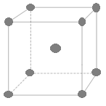 1 bp

Number of atoms per unit cell: 2 0,5 bp
5.2 Calculate the lattice parameter a in pm.
$$ρ=\frac{m_{EZ}}{V_{EZ}}=\frac{atome/uc∙M}{N_{A}∙a^{3}}$$
$a=\sqrt[3]{\frac{\frac{Atome}{EZ}∙M}{ρ∙N_{A}}}$ $a=2,8920∙{10}^{-8}cm=289,20 pm$ 3 bp
5.3 Give a balanced, complete disintegration equation for electron capture. Note both mass number and atomic number for every nuclide.
${}_{24}^{51}{Cr}$+e⁻ ⟶ ${}_{23}^{51}V$+ν_{e} 1bp
5.4 Calculate the half-life of ${}_{}^{51}{Cr}$ in hours from the data given.
$$n=\frac{m}{M}=\frac{2}{50,945}=0,039258mol$$
$N\left(0\right)=0,039258∙N_{A}=2,3641∙{10}^{22}$ 1 bp
$λ=\frac{A\left(0\right)}{N\left(0\right)}=\frac{6,84701∙{10}^{15}}{2,3641∙{10}^{22}}=2,8962∙{10}^{-7}$ 1 bp
$t_{1/2}=\frac{ln2}{λ}=2,39330∙{10}^{6}s=664,80h$ 1,5 bp

5.5 Formulate balanced ion equations for:
a) Oxidation of chromium(III) by hydrogen peroxide,
b) Reduction of chromate by iron(II), and
c) Oxidation of Iron(II) by permanganate.
Explicitly state every stoichiometric coefficient, including “1”.
10 OH⁻ + 2 Cr³⁺ + 3 H₂O₂ ⟶ 2 ${CrO}_{4}^{2-}$+ 8 H₂O 1 bp
8 H⁺ + 3 Fe²⁺ + 1 ${CrO}_{4}^{2-}$ ⟶ 3 Fe³⁺ + 1 Cr³⁺ + 4 H₂O 1 bp
8H⁺ + 5 Fe²⁺ + 1 ${MnO}_{4}^{-}$ ⟶ 5 Fe³⁺ + 1 Mn²⁺ + 4 H₂O 1 bp

5.6 Calculate the fraction of chromium in the alloy in %(w/w).
$17,20∙0,020=0,344 mmol {KMnO}_{4}$ 0,5 bp
$5∙0,344=1,72 mmol{Fe}^{2+}$ 0,5 bp
$25∙0,1-1,72=0,78mmol{Fe}^{2+}$ 0,5 bp
$\frac{0,78}{3}=0,26mmol Cr in 150mg$ 0,5 bp
$m\left(Cr\right)=2,6∙52,0=135,2mg in 1500mg$ 0,5 bp
$p\left(Cr\right)=9,013\%$ 0,5 bp

5.7 State the name of the coordination polyhedron formed by the complex. State the donor atoms explicitly and use only the skeletal structure of the ligands otherwise.
Coordination polyhedron: octahedron 1bp
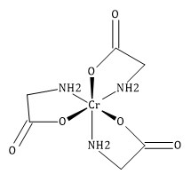 2 bp

5.8 State the number of possible geometrical isomers (=diastereomers!) for the tris-glycinato-chromium(III) complex and all corresponding stereo descriptors. Consider that each ligand molecule contains two different donor atoms.
2 1 bp
fac, mer 0,5 bp each
5.9 Tick the box below the absorption spectrum of ruby.
No. (4) 1,5 bp

5.10 Write down the correct and complete formula of the complex. The structural drawing should make clear which ligands are located in which coordination sphere of chromium.
1 mol CrCl₃H₁₂O₆ ≙ 1 mol Cl⁻
Gentle heating: 1 mol CrCl₃H₁₂O₆ ≙ 2mol H₂O
[CrCl₂(OH₂)₄]Cl . 2H₂O 4 bp

5.11 Occupy the d-orbital schemes of tetrahedral and octahedral voids of Cr³⁺ and Fe²⁺, respectively. Do this by inserting arrows in the usual way.
1bp each – max. 4 bp

5.12 Determine whether FeCr₂O₄ is a normal or an inverse spinel. For that purpose, calculate the LSFE for both Fe²⁺ and Cr³⁺ in both types of voids in units of Δ₀. Then, calculate the LFSE for normal and inverted spinel and state your decision.
Fe²⁺ tetrahedral void:
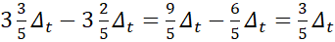
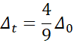
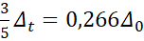 1 bp
Fe²⁺ octahedral void:
0,5 bp
Cr³⁺ tetrahedral void:
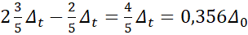 1 bp
Cr³⁺ octahedral void:
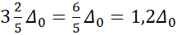 0,5 bp

normal spinel (Fe^{T}Cr^{O}Cr^{O}O₄): LFSE = 0,266 Δ₀ +2∙1,2 Δ₀ =2,666 Δ₀ 0,5 bp
inverse spinel (Fe^{O}Cr^{T}Cr^{O}O₄): LFSE = 0,4Δ₀ + 0,356 Δ₀ +1,2 Δ₀ =1,956 Δ₀ 0,5 bp
attains normal spinel configuration 0,5 bp
total max. 4,5bp

