42nd Austrian Chemistry Olympiad

National Competition

Problem booklet for the theoretical part – June 2nd, 2016

 | bp | rp
1: Some antibiotics
2: Birch sugar
3: A journey through the world of metals
4. Something „Gschmackig’s“ (= tasty) from Tyrol
5: The A to G of nickel complexes
6: Bombastic calorimetry
7: A kinetic mixture
8: Another journey: electro chemistry and equilibrium

Total: .........../60

Name:........................................

Hints

- You have 5 hours to complete the solutions of the competition tasks.
- You may only use this paper, draft paper, a periodic table of elements, the page with the formulae, a not programmable calculator, a pencil, a rubber, and a blue or black biro, nothing else.
- Write your answers in the boxes provided for them. Only these answers will be marked. If you don’t have enough space, then you may write on the draft paper with the remark “belongs to part x.xx“, whereby x.xx means the part of the task in italics. Add this draft paper to the booklet.
- Underline the final result of your calculation.
- You may take the PTE and the draft paper with you after the competition.
- This booklet contains 35 pages without the front page.

Constants and Data

R = 8.314 J·mol⁻¹.K⁻¹ standard conditions: 25°C, 1 bar
N_{A} = 6.0221·10²³ mol⁻¹ 1Å = 10⁻¹⁰ m
F = 96485 A·s·mol⁻¹ 273 K = 0°C
c = 2.998·10⁸ m·s⁻¹
h = 6.626·10⁻³⁴ J·s
q_{el} = 1.602·10⁻¹⁹ A·s

spectrochemical series

I⁻ < Br⁻ < S²⁻ < SCN⁻ < Cl⁻ < F⁻ < OH⁻ < ox < H₂O < NH₃ < en < NO₂⁻ < CN⁻ <CO

Task 1 11 points

Some antibiotics

The Austrian company Sandoz GmbH with their factory in Tirol is the largest producer of antibiotics and the only real producer of penicillin in the western world. The company accounts for approximately two-thirds of the worldwide production of penicillin V, the acid stable penicillin that was discovered in 1951 by two scientists from Kundl.
This penicillin V as well as three other antibiotics provide a small insight into the synthetic paths in organic chemistry.

A. Prontosil

Hint: B shows signals in the molecule peak reagion at m/z = 233 and m/z = 235 in a 3:1 ratio.

  - Draw the constitutional formulae of the compounds B, C, D, E, F, and benzene-1,3-diamine.
B | C
D | E
F | benzene-1,3-diamine

1.2. Why is the step E→F impossible when benzene is used instead of benzene-1,3-diamine?
verbal justification:

1.3. What type of stereoisomerism can occur in F?
B. Chloramphenicol

1.4. Draw the constitutional formulae of the compounds A and B and the configurational formulae of C and E.
A | B
C | E

1.5. Draw the structural formulae of the reactive species in the reaction A→B and D→E and name the respective reaction mechanisms.
A→B  reaction mechanism: | D→E  reaction mechanism:

1.6. Name substance C according to IUPAC.

C. Trimethoprim

Hints:
- Substance B has the name 3,4,5-trihydroxybenzenecarboxylic acid methyl ester.
- Substance E is a mixture of isomers.

1.7. Draw the constitutional formulae of the compounds B, C, D and E and write down the molecular formula of X.
A | B
C | D
E | X

Guanidine (reactant of E→F) is surprisingly basic pK_{B} = 0.35.

1.8. Which effect in protonated guanidine is responsible for this fact? Draw at least two structural formulae in order to show this.
effect:

structural formulae:

D. Penicillin V

1.9. Draw the configurational formulae of the compounds A and B.
A | B

1.10.Write the mechanism of the reaction A→B with structural formulae and „arrows“ for the attacking species. Draw only the parts of the molecules that are involved in this step. For all other parts write „R“ for rest.

1.11. Write down the name of the functional group that is formed in reaction A→B.

Task 2 4 points
Birch sugar

Monosaccharide A is a xylose. This name derives from the Greek word for wood and indicates the occurrence of this sugar in bark (wood sugar). A modified substance (xylitol or birch sugar) is found in birch trees. Xylitol has won relevance for diabetics as a sugar replacement (E 967).

Hint: Substance F is idose and is name according to IUPAC is (2S, 3R, 4S, 5R)-2,3,4,5,6-pentahydroxyhexanal.

2.1. Draw the structural formulae of A – F in Fischer projection.
A | B
C | D
E | F

2.2. Draw the two pyranose sugars F₁ and F₂ formed in the Haworth projection and name both monosaccharides.
F₁ | F₂

2.3. Name the special isomeric relationship between F₁ and F₂.

2.4. Draw the structural formula of the disaccharide in the Haworth projection that is formed through the combination of F₁ and F₂. This substance shows a negative reaction wit Fehling’s solution.

If you cannot determine a structure for B, use this structure to solve the following task. This is not the real structure of B.

2.5. How many stereoisomers exist for B?

Task 3 9 points

A journey through the world of metals

In the Lavant Valley, mining is about to be expanded with a focus on metal Y. There is a binary inorganic compound Z (M = 45.88g/mol) of metal Y with an oxygen/metal ratio of 1:1, containing 69.75% oxygen.

3.1. Determine which metal the mentioned metal Y is and provide your calculation below.

This type of metal can bind oxygen anions as O²⁻, $O_{2}^{2-}$and $O_{2}^{-}$.

3.2. Write down the exact total formula of substance Z.

The metal Y has a density of ρ = 0,534 g∙cm⁻³ and crystallises into a lattice with a = 351 pm.

3.3. Calculate into which cubic lattice the metal Y crystallises.

One possibility to gain the metal barium is the reduction of barite (barium sulphate) with carbon. Amongst others, a chemical compound containing carbon in the oxidation state +IV is produced. The produced metal sulphide is then reprocessed with water and carbon dioxide. The resulting salt is annealed. The hereby resulting metal compound is transformed with aluminium into the metal and aluminium oxide.

3.4. Write down balanced reaction equations for the four discussed processes.

The metal oxide BaO crystallises into a sodium chloride structure type.

3.5. Specify the coordination numbers of the metal and oxide ions in the crystal structure.

Barium forms several oxides. Some selected examples are BaO, BaO₂ and Ba(O₂)₂.

3.6. Write down balanced reaction equations for the formation of the three metal oxides from their elements.

When discharging ozone into a solution of the metal barium in liquid ammoniac, a sepia brown, extremely labile metal ozonide should be formed. Ionic ozonides are vigorously decomposed by water under the formation of oxygen. The resulting solution is alkaline.

3.7. Write down the balanced reaction equation for the reaction of the ozonide ions with water. Assign oxidation states to all atoms.

For the secure storage of large amounts of hydrogen (e.g. for operating a fuel cell) metal hydrides can be used. An example for such a metal hydride is Mg₂NiH_{4.} It is gained by mixing (“ball milling“) magnesium hydride and elemental nickel.

3.8. Calculate the amount of hydrogen in Mg₂NiH₄ in percent by mass.
Simplified working hypothesis: The nickel atoms are arranged face-centred cubic in the unit cell of Mg₂NiH₄ and the Mg-ions fill the tetrahedron gaps. Around each nickel atom four hydrogen atoms are coordinated.

3.9. Draw all nickel atoms (without H atoms) as coloured balls, and one magnesium ion, which you can choose freely, as a triangle into the given unit cell. Indicate the tetrahedron for the chosen magnesium ion with dashed lines.
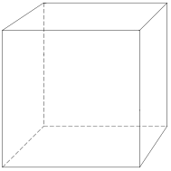

3.10. How many tetrahedron gaps and how many octahedron gaps are there per unit cell?
tetrahedron gap: | octahedron gap:

3.11. Write down the amount of formula units of Mg₂NiH₄ in one unit cell.

The metal hydride is examined by X-ray diffraction. The diffraction of the first order at the (111)-plane occurs in an angle of 11.92° when CuK_{α}-rays are used.

3.12. Calculate the lattice parameter a₀ of the unit cell.

3.13. Calculate the density of Mg₂NiH₄ powder in g/cm³.

Task 4 6 points

Something „Gschmackig’s“(= tasty) from Tyrol

A. The „Tiroler Zelten“

The following ingredients are necessary for the preparation of a tasty „Tiroler Zelten“: 375 g rye flour, 375 g wheat flour, 500 ml lukewarm water, 20 g yeast, 1 tsp salt, 1 tsp caraway, 1 tsp fennel, ½ tsp aniseed, ½ tsp cilantro, 1 egg for brushing and halves of almonds for decoration.

The molecule W, which can be found in the dough for the „Tiroler Zelten“, comprises 70.56% C, 5-93% H – the rest is O. The mass spectrum of substance W is given as spectrum 1.

spectrum 1:
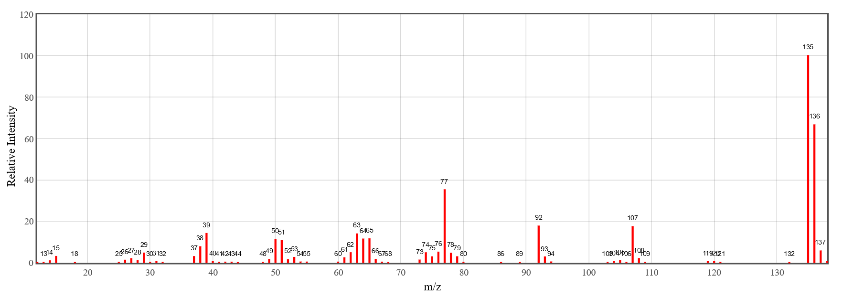

4.1. Calculate the exact total formula of substance W.

Spectrum 2 shows the ¹H NMR of substance W.

4.2. Draw the exact structural formula of substance W.

One of the spices used in the recipe consists of 80-90% of substance X. A combustion analysis of 2.9644g of substance X results in 8.8020g CO₂ and 2.1624g H₂O. The molar mass of substance X is M < 200g∙mol⁻¹.

4.3. Calculate the exact total formula of substance X.

Spectrum 3 shows the ¹H NMR of substance X.
1

3
3
2
2
1

4.4. Draw the structural formula of substance X and mark which H atom is responsible for the signal at 6.06 ppm with an arrow.

4.5. Write down the IUPAC name of substance X without stereo descriptors.

Approximately 50 years ago, Robert Sidney Cahn, Sir Christopher Ingold and Vladimir Prelog published an article titled “Specification of Molecular Chirality” in the renowned scientific journal Angewandte Chemie. It was a comprehensive illustration of the Cahn-Ingold-Prelog system and about to change chemical terminology by introducing the term of chirality. Nowadays the CIP system is used as a specification tool in organic chemistry.

There are two diastereomeres of substance X.

4.6. Denote the both configurations of X by drawing their structural formulae in the boxes provided below and indicate eventual stereo descriptors.

Estragole is isomeric with substance X. Spectrum 4 shows the ¹H NMR of estragole.

Spectrum 4:

4.7. Draw the structural formula of estragole and mark which H atom(s) are responsible for the signal at 3.21 ppm.

B. A mug of mulled wine

Regarding the quality of wine, tannin concentration is an important factor. Due to their qualities, tannins can be categorised into two groups: hydrolysable and condensed tannins. One example for a tannin would be corilagin.

4.8. Mark all chiral centres with an asterisk (*) in the corilagin molecule depicted below and precisely indicate their absolute configuration by labelling the atoms with their stereo descriptors.
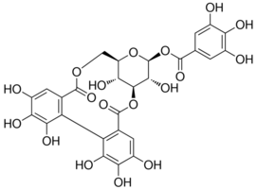
Illustration: corlagin

4.9. Provide a drawing of the heterocyclic compound of corilagin in the Haworth projection. Simplify the structure as depicted below.
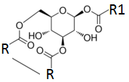

Task 5 10 points

The A to G of Nickel Complexes

This task is about several nickel complexes, their structure, their reactions, their ligands. Each complex is assigned a letter as an identifier as can be seen in this overview

A: [Ni(NH₃)₆]²⁺ B: [Ni(NO₂)₆]⁴⁻ C: [Ni(OH₂)₆]²⁺
D: [Ni(NH₃)₂(OH₂)₄]²⁺ E: [Ni(en)(OH₂)₄]²⁺
F: [Ni(en)₃]²⁺ G: [Ni(CO)₄]

5.1. Hereunder some names of complexes are given. If you find some of the ones specified above, fill in the corresponding letter. (Note: Whereas there will be no negative marks for this part of the task in total, wrong answers will lead to deduction of points.)
hexaamminenickel(III) _____ hexaaquanickel(II) _____
hexaethylendiaminonickel(II) _____ hexanitratonickel(II) _____
diamminetetraaquanickel(II) _____ tetraaquaethylendiaminonickel(II) ______
tetracarbonylnickel(II) _______ tetracarbonylnickel(0) _____

Let us now take a closer look at the three octahedral complexes A, B and C.

5.2. Write down the complete electron configuration of the central atom in these complexes.
5.3. Draw a diagram showing the splitting of the d-orbitals of Ni in the octahedral complex. Decide which magnetic properties you expect.
O paramagnetic O diamagnetic

For the complexes A, B, C values of Δ_{O} have been measured. You can find them in the following table in different units of energy.

5.4. Fill in the missing values for Δ_{O} . Into the first row write the letter (A, B, C) for the corresponding complex.
complex
Δ_{O}/cm⁻¹ | 8500 | 10800
Δ_{O}/eV |  | 1.34 | 1.61
Δ_{O}/kJ mol⁻¹ | 101.68 |  | 155.51

5.5. Calculate the ligand field stabilization energy for the complex with Δ_{O}=10800cm⁻¹ in eV.
5.6. In this calculation you did not have to consider the pairing energy P because … (tick right answer/s)
O ... it is only an approximation, P is negligible.
O ... you only have to consider P in orbitals that lie higher in energy as the others.
O ... the Ni central atom in the spherical ligand field has the same number of paired spins.
O Not true at all. One has to consider P and I did that.

The following two chemical equlibria exist in dilute aqueous solutions at 298 K (en = ethane-1,2-diamine):
(1) [Ni(OH₂)₆]²⁺ + 2 NH₃ ⇌ [Ni(NH₃)₂(OH₂)₄]²⁺ + 2 H₂O
(2) [Ni(OH₂)₆]²⁺ + en ⇌ [Ni(en)(OH₂)₄]²⁺ + 2 H₂O
It is
for (1) ln K_{c} = 11.60 and Δ_{R}H° = -33.5 kJ for (2) ln K_{c} = 17.78 and Δ_{R}H° = -37.2 kJ

5.7. Tick the right answers a) which complex is thermodynamically more stable.
b) the name of the effect causing this stability.
a) O complex D [Ni(NH₃)₂(OH₂)₄]²⁺ O complex E [Ni(en)(OH₂)₄]²⁺
b) O inert-pair-effect O chelate effect
O resonance O trans effect

5.8. Calculate the reaction entropies Δ_{R}S° for (1) and (2).
for reaction (1)

for reaction (2)

Equlibrium (3) is given as: [Ni(NH₃)₂(OH₂)₄]²⁺ + en ⇌ [Ni(en)(OH₂)₄]²⁺ + 2 NH₃

5.9. For reaction (3) calculate Δ_{R}H°, Δ_{R}S° and Δ_{R}G° .

5.10. Complex D [Ni(NH₃)₂(OH₂)₄]²⁺ has two stereo isomers. Draw them using the octahedral skeletons. Assign the appropriate stereodescriptors.
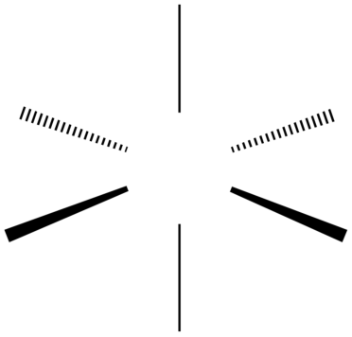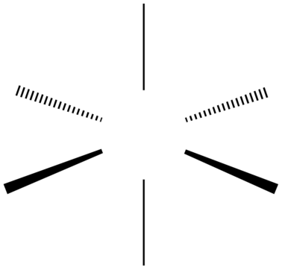

5.11. Draw the Λ-isomer of complex F [Ni(en)₃]²⁺ using the skeleton. Draw en in the way shown below.
en =
Λ [Ni(en)₃]²⁺

Let us finally consider the diamagnetic complex G [Ni(CO)₄] with the eyes of valence bond (Pauling) theory.

5.12. In the VB-scheme for complex G ...
a) draw the electrons (electron pairs) of the Ni central atom with ↑ and ↑↓ respectively.
b) mark the orbitals occupied by electron pairs from the ligands with an X.

3d |  |  |  |  | 4s | 4p |  |  | 4d

5.13. Denote the hybridization of the Ni central atom in complex G and choose the geometrical shape resulting of this hybridization.
hybrid: _______________ shape: O octahedral O tetrahedral
O square planar O trigonal prismatic

5.14. One of the following MO-schemes shows the energies for the molecular orbitals of CO in correct sequence. Choose the right scheme by correctly „occupying“ it with electrons (arrows) and indicating the LUMO.

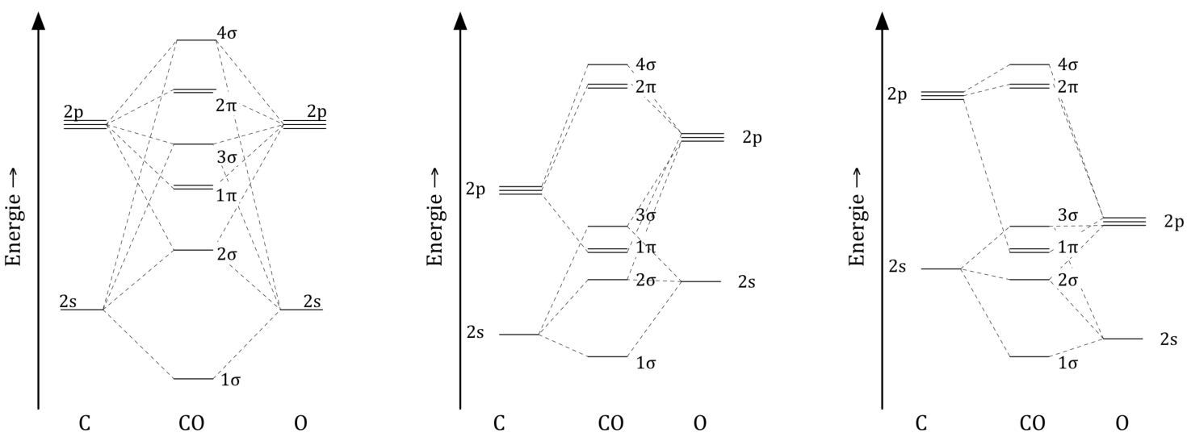

Task 6 5 points

Bombastic Calorimetry

In this task all data given and asked for are referred to standard conditions .
Two isomeric, liquid hydrocarbons (C₈H₈) have been investigated: cycloocta-1,3,5,7-tetraene and styrene = vinylbenzene = ethenyl benzene. They were burnt in a bomb calorimeter with an excess of oxygen so that H₂O_{(l)} and CO_{2(g)} were formed. Ignition was achieved by means of a wire whose heat of combustion in both cases was Q_{wire} = -30.0 J.
The lab assistand carrying out the experiments labeled the samples “A“ and “B“, conducted the measurements, wrote down the results and then left for lunch. On his return, however, he unfortunately had forgotten which substance actually was “A“ and which was “B“.
The lab journal showed these data:

compound | initial weight m/g | heat measured Q/J
A | 0.7834 | -34181
B | 0.6548 | -27623

Also known are Δ_{f}H° (H₂O_{(l)}) = - 285.8 kJ mol⁻¹ and Δ_{f}H° (CO_{2(g)}) = - 393.5 kJ mol⁻¹

6.1. Give a balanced equation for the combustion including the symbols for the states of matter.
6.2. Calculate the molar standard enthalpies of combustion Δ_{c}H° of A and B.
for compound A

for compound B

6.3. Calculate the molar standard enthalpies of formation Δ_{f}H° of A and B.
In case you did not get a result in 6.2. use Δ_{c}H°_{A} = -4581 kJ mol⁻¹ and
Δ_{c}H°_{B}= -4431 kJ mol⁻¹.
for compound A

for compound B

6.4. According to the standard enthalpies of formation, one of the substances should be more stable with regard to dissociation in the elements than the other.
This is… (tick the right circle!).
O compound A O compound B
6.5. According to Hückel’s rule one compound is aromatic. Into the brackets write the number of π-Elektrons of the ring systems and mark the aromatic compound.
O cyclooctatetraene (____) O styrene (____)
6.6. Assign which compound was which sample by correctly filling in A or B respectively.
______ was cyclooctatetraene ______ was styrene

It is possible to estimate enthalpies of combustion using a so called incremental system. Therefore it is assumed that a certain bond or a certain group of atoms in the gasphase gives the same contribution (an increment, Δ_{c}H_{I}°) to the enthalpy of combustion regardless of its chemical surrounding. For every substance the enthalpy of evaporation or of sublimation has to be added to the sum of increments.

As an example the calculation for cyclooctatetraene is shown:

Δ_{c}H° = 8·Δ_{c}H_{I}°(C-H) + 4 · Δ_{c}H_{I}°(C-C) + 4 · Δ_{c}H_{I}°(C=C) + Δ_{c}H_{I}°(Ring) + Δ_{vap}H° =
= 8 · (-226.1) - 4 · (206.4) - 4 · (491.5) – 4.2 + 43.1 =
= -4561.5 kJ

bond | Δ_{c}H_{I}° / kJ mol⁻¹ | bond | Δ_{c}H_{I}° / kJ mol⁻¹
C-H | -226.1 | C-C | -206.4
C=C in | -491.5 | C=C in | -484.4
ring | -4.2

Enthalpy of evaporation: Δ_{vap}H°(styrene) = 43.5 kJ mol⁻¹

6.7. For styrene calculate the standard enthalpy of combustion according to the incremental system.

By its very basic assumption (always the same contribution of energy independent of surrounding) the incremental system completely disregards stabilizing effets such as resonance (mesomerism) or delocalization, wich are substantial for aromatic compounds.

6.8. For both hydrocarbons calculate the stabilization energy through a comparison between the calculated and the measured enthalpies of combustion.
for cyclooctatetraene

for styrene

Task 7 7 points

A kinetic mixture

A. Nitrogen oxides

An important step in the technical synthesis of nitric acid is the oxidation of nitrogen oxide to nitrogen dioxide with the aid of oxygen from air:

2 NO(g) + O₂(g) → 2 NO₂(g)

The reaction obeys the following kinetic law: $v=k∙{\left[NO\right]}^{2}∙[O_{2}]$

7.1. Put a cross into the box where the factor of the change in rate matches the concentration change.
Change of concentration | The rate changes with the factor
Change of concentration | 1 | 2 | 4 | 8 | 16 | $\frac{1}{2}$ | $\frac{1}{4}$ | $\frac{1}{8}$ | $\frac{1}{16}$
[O₂] quadrupled, [NO] unchanged
[O₂] unchanged, [NO] quadrupled
[O₂] unchanged, [NO] halved
[O₂] halved, [NO] quadrupled
[O₂] quadrupled, [NO] halved

The initial rate of the above reaction remains the same, if the temperature is raised from 460°C to 600°C, and the initial concentrations are halved.

7.2. Calculate the activation energy of the reaction.

B. The iodation of acetone

Measuring the rate of a chemical reaction and its dependence on several parameters (concentration of involved species, temperature, pressure, and catalysts) enables the chemist to draw conclusions about the reaction mechanism and thus about the detailed way of the reaction.

In compulsory lab lessons at a Viennese High School the iodation of acetone under acid catalysis is investigated:

The reaction does not proceed in one step, but in several ones, one of them being the rate determining step (RDS).
The rate equation of the reaction is given:

$v=-\frac{∆[I_{2}]}{∆t}=k∙{\left[Ac\right]}^{a}∙{\left[H_{3}O^{+}\right]}^{b}∙{\left[I_{2}\right]}^{c}$

The students have to mix various volumes of the involved reaction partners, knowing their initial concentrations. Additionally they have to measure the time until the colour of iodine disappears, therefore

$∆[I_{2}]$ = ${\left[I_{2}\right]}_{0}-0={\left[I_{2}\right]}_{0}$.

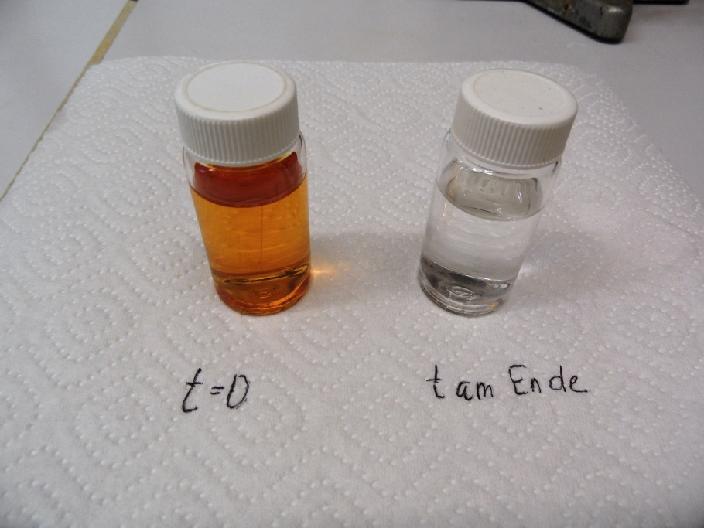

Reaction flask at the beginning (or during) and at the end of measurements
(“t am Ende” = t at the end)

The values of four experiments are given in the table below. The volumes refer to the stock solutions of the following substances which were mixed to a final volume of 20.0 mL:

c (I₂) = 0.0101 mol·L⁻¹; c (HCl) = 1.96 mol·L⁻¹; pure acetone (ρ = 0.790 g·mL⁻¹);

Immediately after the addition of acetone the stop clock was started. When the solution first got colourless the clock was stopped. The corresponding times are also given in the table.

try | V (H₂O) mL | V (HCl) mL | V (I₂) mL | V (Ac) mL | t in s
1 | 7.0 | 8.0 | 3.0 | 2.0 | 39.3
2 | 11 | 4.0 | 3.0 | 2.0 | 80.1
3 | 8.0 | 8.0 | 2.0 | 2.0 | 26.0
4 | 7.5 | 8.0 | 3.0 | 1.5 | 53.0

7.3. Calculate the amount of acetone in 1.00 L (= „concentration of Ac“).

7.4. Fill the missing values into the table, calculation the individual initial concentrations and the reaction rates of the four experiments.
try | c (H₃O⁺) mol·L⁻¹ | c (I₂) mol·L⁻¹ | c (Aceton) mol·L⁻¹ | v in mol·L⁻¹·s⁻¹
1
2
3
4

7.5. Write down an equation for the differential reaction rate of the iodation of acetone using the right integer reaction orders.
7.6. Calculate a mean value of the rate constant with the right units.

7.7. Put a cross (crosses) left of the reaction equation which corresponds to a possible RDS which matches the differential rate law..

C. The Rice-Herzfeld-Mechanism

Radical chain reactions often show a very complex differential rate law. In some cases, however, relatively simple equations appear. One example is the pyrolysis of ethanal to methane and carbon dioxide.
The differential rate law for this process is given:

$$\frac{d[CH_{4}]}{dt}=k_{EXP}∙{\left[CH_{3}CHO\right]}^{\frac{3}{2}}$$

In the year 1934 F. O. Rice and K. F. Herzfeld were able to explain this more or less simple law by using a complex mechanism. Their proposal was four elemental steps:

Start: CH₃CHO → ⦁CH₃ + ⦁CHO k_{a}
Propagation: CH₃CHO + ⦁CH₃ → CH₄ + CH₃CO⦁ k_{b}
Propagation: CH₃CO⦁ → ⦁CH₃ + CO k_{c}
Termination: ⦁CH₃ + ⦁CH₃ → C₂H₆ k_{d}

7.8. Write down a balanced equation for the pyrolysis reaction.

7.9. Write the formulae for the unstable particles of the propagation reactions into the two boxes.

7.10. Proof the differential rate law given above, assuming a steady state mechanism for the unstable particles of the propagation reactions.

7.11. Write down a relation between k_{EXP} and the rate constants of the elemental steps.

Task 8 8 Points

Another journey: electro chemistry and equilibrium

A. Another metal: Chromium

The following figure shows the Latimer-diagrams of some chromium species at pH = 0 and
pH = 14. All numbers have the unit V.
1.72
2.10
0.55
–0.42
0.95
–0.74
–1.33
–0,72
–0.72
Cr(V)
Cr(IV)
Cr³⁺
Cr²⁺
Cr
Cr
Cr(OH)₃
Cr(OH)₄–
–0.11
–1.33
8.1. Calculate the three missing $E^{O}$-values and write the respective results on the corresponding lines.

8.2. Are Cr(V) and Cr(IV) stable against disproportionation? Give reasoning for your answers using inequalities.

8.3. Calculate the equilibrium constant for the disproportionation of Cr(II) at 25°C.

8.4. Calculate the solubility product of Cr(OH)₃ at 25°C.

8.5. Calculate the solubility of Cr(OH)₃ at 25°C. If you didn’t get a result in 8.4. , you may use 1.0·10⁻²⁸ (this is not the correct value!).

B. The “Voltameter”

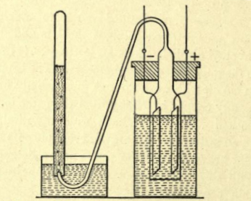
The picture on the right side shows a „Voltameter“ (not voltmeter!), a device to measure amounts of electrical charge. The liquid in the right vessel is a 10% K₂SO₄-solution, in which, applying a direct voltage, obviously gases evolve as it is depicted.
You also have some data at hand, which will be necessary to solve the problems in this tasks:

$U_{Z}\left(H_{2}\right)=-0.58 V$ (at platinum)
$U_{Z}\left(O_{2}\right)=+1.77 V$ (at platinum)
$E^{O}\left(K^{+} | K\right)=-2.92$ V; $U_{P}≈0$ V
$E^{O}\left(S_{2}O_{8}^{2-} | SO_{4}^{2-}\right)=+2.01$ V; $U_{P}≈0$ V

8.6. Which products deposit at the platinum-cathode and at the platinum-anode? Give your reasoning comparing all possible decomposition voltages.

8.7 Write down a balanced equation for the overall electrolysis reaction.

Through the voltameter a current of 805 mA flows for 7.00 minutes. The current is totally used for the deposition of the products. The temperature of the gases in the left tube is 20.0°C, the pressure of the gases 998 mbar.

8.8. Calculate the amount of the deposited products, and from there the total volume of the gas in the left tube of the picture.

C. An acid constant and its consequences

A student in an analytical training lab has the task to determine the protolysis constant of benzoic acid. He proceeds as follows:

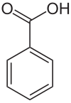
- He starts with the production of a saturated aqueous solution of benzoic acid, which then contains 2.90 g/L at 25°C.
- He fills the solution into a conductivity cell. He measures a specific conductivity of κ = 0.453 mS·cm⁻¹.
- Looking into tables the student finds values for the equivalece conductivity at infinite dilution:
$λ_{0}\left(H^{+}\right)=350$S·cm²·mol⁻¹; $λ_{0}\left(C_{7}H_{5}O_{2}^{-}\right)=32.4$S·cm²·mol⁻¹;

8.9. Calculate the molar concentration of the saturated solution of benzoic acid using the unit mol·cm⁻³.

8.10. Calculate the protolysis degree of benzoic acid and the protolysis constant of the acid.

To be sure, that the concentration calculated in 8.9. is the right one, the student titrates
10.0 mL of the saturated solution with 0.0100 M NaOH.

8.11. Calculate the volume of NaOH, which was titrated by the student, if the result of 8.9. is right.

8.12. Calculate the pH of the solution at the end point of the titration.

Foto: Manfred Kerschbaumer
https://commons.wikimedia.org/wiki/Category:Voltameters?uselang=de#/media/File:Voltametro_a_gas_-_Monroe_Hopkins.png; 29.5.2016

