40th Austrian Chemistry Olympiad

National Competition




Name:........................................

Theoretical Part – June 12th, 2014

Task 1, „Titanium and other metals“: ........./44/15
Task 2, „Some Equilibria“: ........./38/13
Task 3, „Kinetics and Thermochemistry“: ........./43/15
Task 4, „Heterocycles with Nitrogen“: ........./49/17

Total: .........../60

Hinweise
- You have 5 hours to complete the solutions of the competition tasks.
- You may only use this paper, draft paper, a periodic table of elements, a table with a scheme for finding point groups, a non programmable calculator, and a blue or black biro, nothing else.
- Write your answers in the boxes provided for them. Only these answers will be marked. If you don’t have enough space, then you may write on the back of the pages with the remark “belongs to part x.xx“, whereby x.xx means the part of the task in italics. You may take the PTE and the draft paper with you after the competition.
- This booklet contains 30 pages without the front page.

Constants and Data

R = 8.314 J/mol.K standard conditions: 25°C, 1 bar
N_{A} = 6.0221·10²³ mol⁻¹ normal conditions: 0°C, 1.013 bar
F = 96485 A·s/mol 1Å = 10⁻¹⁰ m
h = 6.626·10⁻³⁴ J·s aof solids = 1
c = 2.997·10⁸ m·s⁻¹ 273 K = 0°C
normal air pressure: 1.013 bar

Scheme for determination of point groups
(nein = no; ja = yes; spezielle Gruppen = special groups; gerade = even; mehrere = more than two)
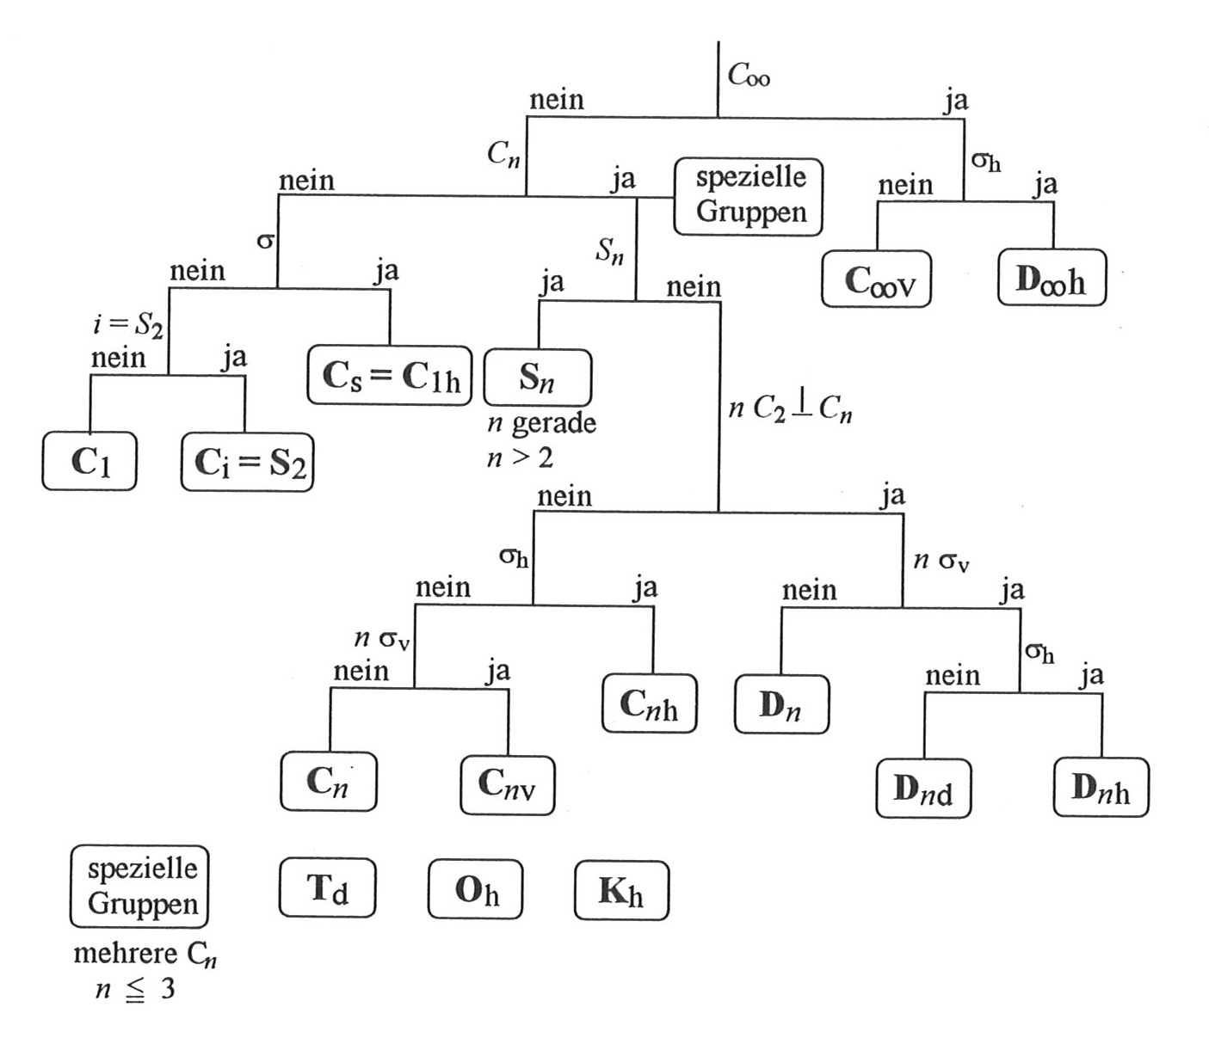

Formulae

amount of substance | $n=\frac{m}{M}$
molar concentration | $c=\frac{n}{V}$
mass density | $ρ=\frac{m}{V}$
equation of ideal gases | $p∙V=n∙R∙T$
change of state variables (functions) | $$∆X=X_{ENDE}-X_{ANFANG}$$
free standard reaction enthalpy | $$∆G^{O}=∆H^{O}-T∙∆S^{O}$$
T-dependency of the reaction enthalpy | $∆H\left(T_{2}\right)=∆H\left(T_{1}\right)+∆C_{P}∙∆T$
T- dependency of the reaction entropy | $∆S\left(T_{2}\right)=∆S\left(T_{1}\right)+∆C_{P}∙ln\frac{T_{2}}{T_{1}}$
free standard reaction enthalpy and equilibrium | $$∆G^{O}=-R∙T∙lnK$$
free standard reaction enthalpy and redox potential | $$∆G^{O}=-z∙F∙∆E^{O}$$
Kapustinskii-Equation | $ΔH=-\frac{N_{ion}\left|z_{-}z_{+}\right|κ}{r_{0}}(1-\frac{d^{*}}{r_{0}})$
Difference of potentials | $∆E=E_{CAT}-E_{AN}= E_{RED}-E_{OX}$
Equilibrium constant (Y = concentration variable) | $K=\frac{Y_{C}^{u}∙Y_{D}^{v}}{Y_{A}^{x}∙Y_{B}^{z}}$
acid constant | $K_{A}=\frac{\left[H_{3}O^{+}\right]∙[A^{-}]}{[HA]}$
p-values | $\text{p}X=-logX$
Equation for the radioactive decay | $A_{t}=A_{0}∙e^{-λ∙t }$
Half life of the radioactive decay | $τ=\frac{ln2}{λ}$
Rate of reaction | $v=\frac{dc}{dt}$
1storder reactions | $k∙t=ln\frac{c_{0}}{c_{t}}$
2ndorder reactions | $k∙t=\left(\frac{1}{c_{t}}-\frac{1}{c_{0}}\right)$
Orthogonal triangle | $\sin{α=\frac{opposite leg}{Hypotenuse}}$
Orthogonal triangle | $\cos{α=\frac{adjacent leg}{Hypotenuse}}$
Energy of radiation | $E=h∙ν=\frac{h∙c}{λ}$
Spin-only formula | $μ=\sqrt{n\left(n+2\right)}μ_{B}$

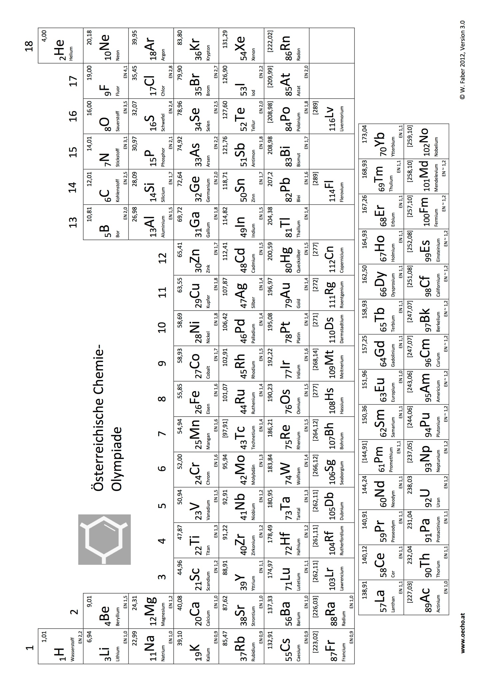
Task 1 15points
Titanium and other metals

A. From the ore to the element

In the close surrounding of Deutschlandsberg aside from the heaviest mountain crystal the biggest titanite crystal of the alpine region was found in Styria.
Titanite is a titanium and calcium containing silicate with 24.42% Ti, 20.44% Ca and 14.33% Si.

1.1. Calculate the empirical formula of titanite.
formula:
calculations:

Ilmenite or titanic iron ore (FeTiO₃) is more important in an economical way. From this ore TiO₂ is manufactured (reaction A), which is then converted to Ti using the so called Kroll-procedure (reactions B, C, D).

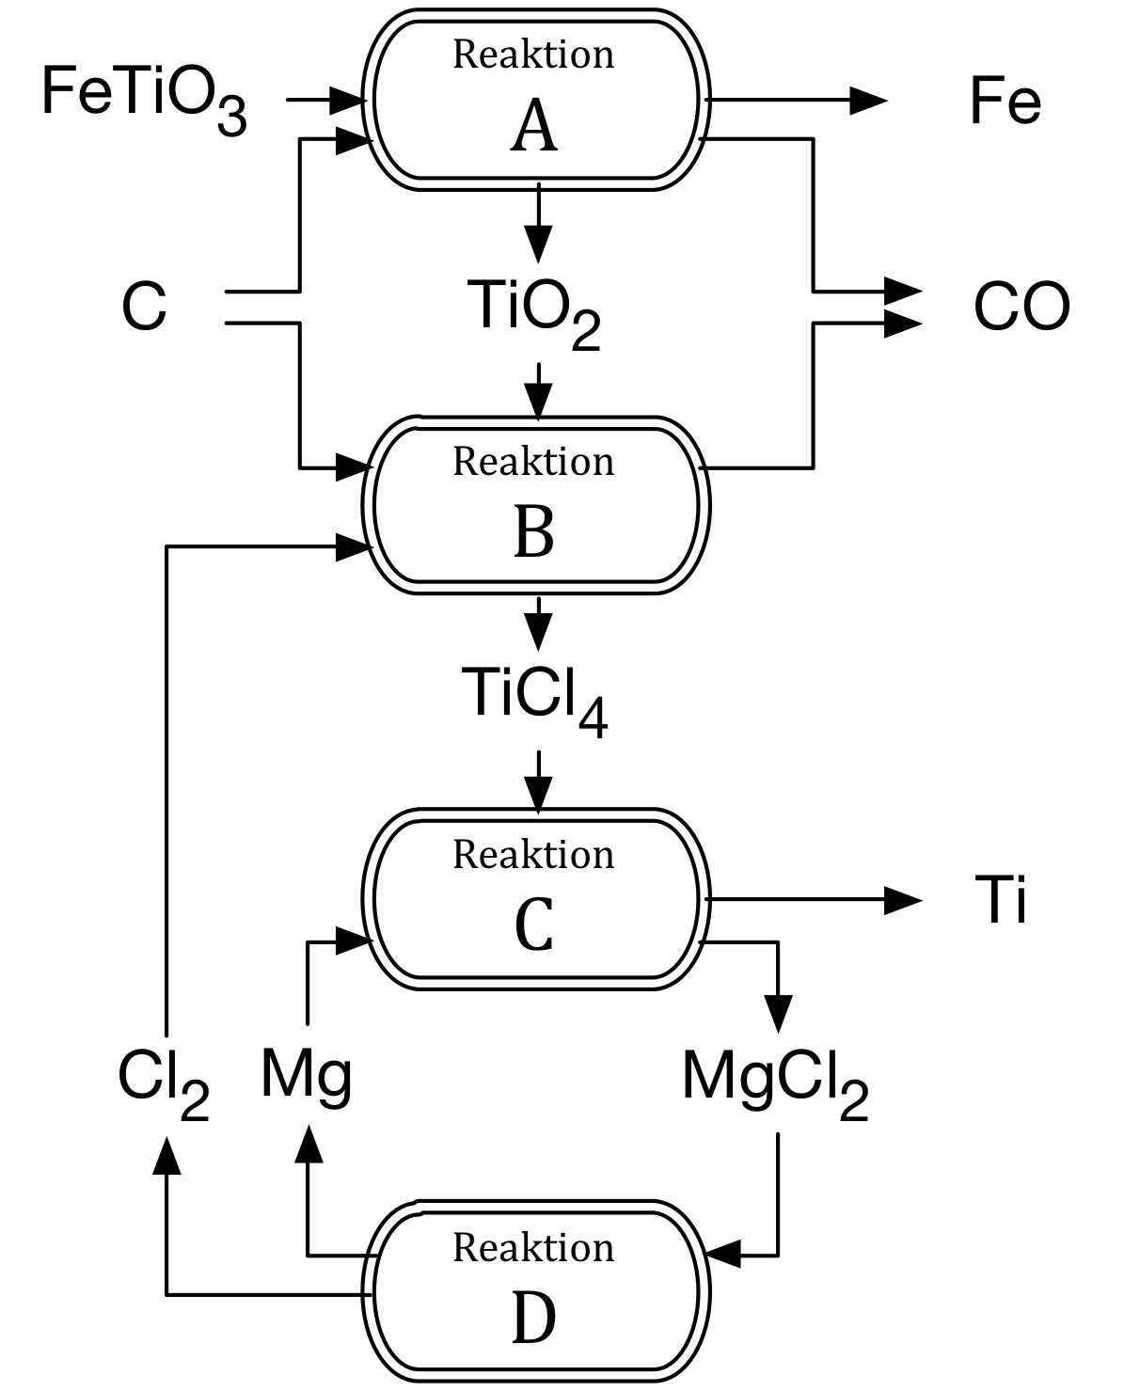
reaction
reaction
reaction
reaction

1.2. Write down balanced equations for the reactions in the scheme and derive from them an overall equation for the depicted process.
A:
B:
C:
D:
overall:

1.3. 1000 kg of the reaction mixture according to the overall equation were used. Which maximum mass of titanium may be generated starting from these 1000 kg?
mass of Ti:
calculations:

1.4. Which process is used to execute reaction D?

Ilmenite serves for the synthesis of Ti and TiO_{2·}. It is also the main primary stuff for the production of catalysts by the company CERAM, as well as raw material of the company EPCOS-TDK to manufacture electro-ceramic compounds. One example is barium titanate(IV), which is used in PTC-resistances, e.g as overheat control in hair-dryers.

1.5. Complete the equation for the synthesis of barium titanate(IV) from TiO₂:
BaCO₃ +

The element titanium itself occurs with 5 stable isotopes from ⁴⁶Ti to ⁵⁰Ti.
The radio nuclide⁴⁵Ti (β⁺, t_{1/2} = 3,078h) can be generated artificially.

1.6. Write down the complete equation forthe radioactive decay of ⁴⁵Ti.
A radioactive marked sample of FeTiO₃with a specific activity of 65.91 Bq/g was prepared. For control purposes 48.5 g were put aside. Another portion of this FeTiO₃-sample (86.2 g) underwent all the reactions of the above scheme (A, B, C, D). After 210 minutes the activity of the totally produced Ti was 2068 Bq.

1.7. What was the specific activity of the sample put aside after 3.0 hours?
specific activity after 3.0 hours:
calculations:

1.8. Calculate the overall yield of Ti of the reaction sequence (A,B,C,D) based on the starting amount of FeTiO₃.
yield in %:
calculations:

B. Other Ti-compounds–crystal lattice

In trying to reduce TiO₂ directly using coke with additional access of air, a mixture of crystals of titanium nitride TiN and titanium carbide TiC is produced. Titanium nitride is known for its hardness and therefore used as construction material. Usually it is mounted in thin layers on other materials.
The lattice energy of TiN is −8033kJ/mol. The radius of the Ti³⁺-ions is 0.67Å.

1.9. Write down the electron configuration of Ti³⁺.

It is possible to calculate the lattice energy using the Kapustinskii-equation if the ionic radii are known. In other cases the equation is used to calculate the ionic radii, if – as it is in this case – the lattice energy is known.

1.10. Calculate the ionic radius of N³⁻using the Kapustinskii-equation. Show your calculations.
(d* = 34.5 pm; κ = 1.21·10⁵ kJ·pm/mol)
Ionic radius of nitride N³⁻:
calculations:

Titanium carbide is very hard and is used due to this property. Especially remarkable seems to be the existence of the molecule Ti₈C₁₂ verified in 1992. The structure of it is debatable. Linus Pauling showed in his article arguments for a cub-like setting (structure in the middle) which is controversial to the structure depicted to the left below. To the right, the front part of the cube is shown in detail.
The titanium atoms (circles) occupy the corners, 2 C-atoms (black circles) are positioned on each face of the cube.

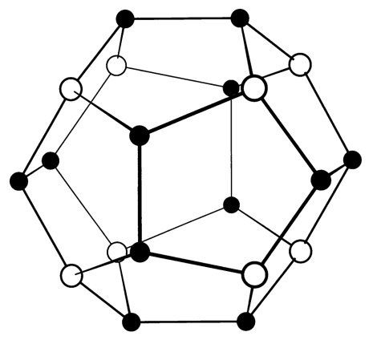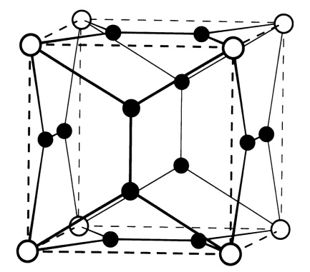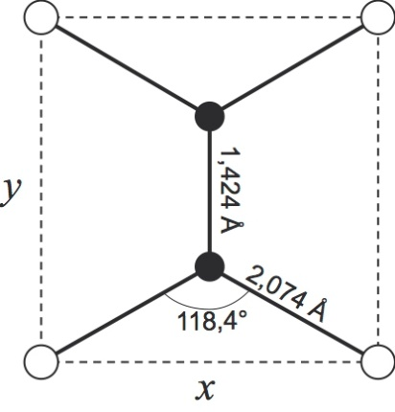

1.11. Calculate the lengths of x and y using this information.
x: | y:
calculations:

C. Complexes of chromium and cobalt

Five coordination compounds are in discussion:
(a) [CoBr(NH₃)₅]SO₄
(b) [Co(NH₃)₅SO₄]Br
(c) tetraaquadichloridochromium(III)-chloridedihydrate
(d) pentaaquachloridochromium(III)-chloride hydrate
(e) K₃[CoF₆]

1.12. Write down the missing name or formula respectively for each of the compounds (a) to (e).
(a)
(b)
(c)
(d)
(e)

These 5 compounds are filled in 5 vessels which are labelled I to V. Due to carelessness the list with allocations was lost. Some experiments however showed:

- Aqueous solutions of III, IV and V generated a white precipitate with AgNO₃.
- An aqueous solution from vessel I gave a white precipitate with BaCl₂.
- Silver ions in excess precipitated 3.28 g of AgCl from an aqueous solution in vessel III.
- 5.34 g from vessel V lost 0,361 g on drying.
- The molar mass of II was determined: 290.23 g/mol.

1.13. Match (a) to (e) with the roman numbers I to V.
I: | II: | III: | IV: | V:
Give your reasoning for the classification using either calculations or chemical equations.

1.14. How do you call the constitution isomerism of (a) and (b)?
1.15. How many diastereomeres may occur in the case of the cation of (c)? Give also the prefixes which you use in naming them.

In a spectrum, (e) shows a significant band at 13100 cm⁻¹. The spin pairing energy for this complex amounts to 200 kJ/mol.

1.16. Calculate Δ_{O} in kJ/mol.
Δ_{O} =
calculation:

1.17. Sketch a d-orbital scheme for the complex in (e)

1.18. Calculate the magnetic moment in units of μ_{B}.
μ=
calculation:

Task2 13points
Some Equilibria

A. Electrochemical Equilibria – Alkaline Cell

Manganese dioxide (MnO₂) is reduced at the cathode of a modern alkaline cell. This reaction takes place in a strongly alkaline medium and incorporates different reactions and various manganese species. The following reactions show a simplified description of the real reactions, they are not to be looked at as complete description.
The following potentials were measured for these processes:

Zn + 2 OH⁻ ⇌ ZnO + H₂O + 2e⁻ E⁰₁ = 1.28 V
2 MnOOH + H₂O + Zn ⇌ 2 Mn(OH)₂ + ZnO E⁰₂ = 1.06 V
2 Mn(OH)₃ + 2e⁻ ⇌ 2 Mn(OH)₂ + 2 OH⁻ E⁰₃ = 0.15 V
Mn₂O₃ + 3 H₂O + 2e⁻ ⇌ 2 Mn(OH)₂ + 2 OH⁻ E⁰₄ = -0.25 V
Mn²⁺ + 2e⁻ ⇌ Mn E⁰₅ = -1.18 V
Mn(OH)₂ + 2e⁻ ⇌ Mn + 2 OH⁻ E⁰₆ = -1.56 V

The first reduction step yields manganese with the oxidation number +3. In different books three species for this oxidation number are mentioned: Mn₂O₃, MnOOH, and Mn(OH)₃.

2.1. Write down the reaction equations for the generation of MnOOH and Mn(OH)₃respectively, starting from Mn₂O₃ using water as reaction partner.

2.2. Calculate the free standard reaction enthalpy for the reaction Mn₂O₃→Mn(OH)₃.
ΔG⁰=
calculation:

2.3. Calculate the free standard reaction enthalpy for the reaction Mn₂O₃→MnOOH.
ΔG⁰=
calculation:

2.4. Calculate the solubility product of Mn(OH)₂.
K_{SP} =
calculation:

B. The coral reef

There is a big fear that due to environmental influences the pH of the oceans may decrease in the next centuries, and therefore the sea will acidify. This may cause particularly extreme damage in the building of the lime frame of stone corals, because this texture is only possible at sufficient high pH values.
The chalk skeleton consists of CaCO₃, which is formed as orthorombical aragonite. The constant calcium ion concentration in sea water amounts to a mean value of 0.42 g/L, the constant total concentration of inorganic carbon as H₂CO₃, HCO₃⁻and CO₃²⁻in sea water amounts to 2.3·10⁻³mol/L.

K_{SP} (CaCO₃) = 8.7·10⁻⁹
Carbonic acid: K_{A1} = 4.3·10⁻⁷ und K_{A2} = 5.6·10⁻¹¹.

2.5. Calculate the minimum concentration of carbonate ions in sea water in order to build the lime frame.
$$\left[CO_{3}^{2-}\right]=$$
calculation:

2.6. Calculate the (highest ) pH, where the lime starts to dissolve.
pH =
calculation:

C. A mixture of acids

You are given acetic acid with an initial concentration of c = 0.100 mol/L.
Acetic acid: pK_{A} = 4.76.

2.7. Calculate the pH of this solution. Neglect the auto protolysis of water.
pH =
calculation:

An equal volume of diluted sulphuric acid is added to the above solution. As a consequence the pH drops to a value 0.300 units less than in case 2.7.
Sulphuric acid: pK_{A1} = -2.00 und pK_{A2} = 1.92.

2.8. Give for the concentrations of all particles in this mixture numbers or terms with variables, whereby you should show reasonable assumptions about negligible species.

2.9. Calculate the concentration of the diluted sulphuric acid, which is added to the solution of acetic acid.
c =
calculation:

2.10. Give reasons for your assumptions in 2.8.

Task3 15points
Kinetics and Thermodynamics

A. Two kinetic problems

In the lab for advanced physical chemistry a student investigates two reactions, which seem to be very similar, at least if you look at the equations:
(1)

(2)

Concerningreaction (1):
The student performed three experiments by mixing different volumes of t-butylbromide with different volumes of water each in water free propan-2-ol at 25°C.The total volume of each solution was 50.0mL. M (t-BuBr) = 137 g/mol; ρ (t-BuBr) = 1.21 g/mL;
The totally generated HBr was separated after one hour in each case, and after that titrated with silver nitrate solution (c = 0.0500 mol/L). Thereby the following volumes were consumed:

Experiment | V (t-BuBr)/mL | V (H₂O)/mL | V (AgNO₃)/mL
1 | 1.20 | 1.50 | 10.6
2 | 1.80 | 1.50 | 15.9
3 | 1.80 | 2.00 | 15.8

3.1. Write down the differential rate law for reaction (1) and give proof by a short calculation.
rate law:
calculation:

3.2. Calculate the initial concentration of t-butylbromide.
exp1: c₀ (t-BuBr) = | exp2: c₀ (t-BuBr) =
calculation for one example:

3.3. Calculate the concentration of t-butylbromide after one hour for experiment (1) and (2).
c_{t} (1) = | c_{t} (2) =
calculation for one example:

3.4. Calculate the rates in experiment 1 and 2 using the differential rate law, and thereby find also a mean value for the rate constant.
v(1) = | v(2) =
k =
calculation:

Concerning reaction (2):
In this case the student determined the kinetic situation in another way. He filled 54.0 g Na⁺CH₃O⁻ in a 500 mL volumetric flask and dissolved it in water free methanol filling it up to the mark. He did quite the same with 94.9 g methyl bromide. The two mixtures were poured together in one vessel and a stop clock was started.
After 30, 60, 90, 120 and 150 minutes 50.0 mL each of the reaction mixture were poured into
50.0 mL of a silver nitrate solution (c = 0.100 mol/L). The silver bromide generated was filtered off, and the filtrate was titrated with NH₄SCN solution (c = 0.100 mol/L). The titration volumes for the formation of AgSCN are given in the table.

t /min | 30 | 60 | 90 | 120 | 150
V (SCN⁻)/mL | 41.8 | 33.9 | 26.3 | 18.9 | 11.6

3.5. Which reaction order do you suppose based on the chemical system in question?
reaction order:

3.6. Calculate the initial concentrations of the starting products.
c₀(methyl bromide) = | c₀(sodium methylate) =
calculation:

3.7. Calculate the concentrations of methyl bromide and sodium methylate respectively after 30, 60, 90, 120, and 150 minutes.
c_{t}(30) = | c_{t}(60) = | c_{t}(90) =
c_{t}(120) = | c_{t}(150) =
calculation for one example:

3.8. Proof your assumption in part 2.7. by a calculation and find a mean value of the rate constant.
k (30) = | k (60) = | k (90) =
k (120) = | k (150) = | K_{M} =
calculation for one example:

B. Four (extraordinary?) compounds

In this task we consider four molecular compounds A, B, C, and D, which contain exclusively non metals. In every of these four binary compounds the same element X is bound to another element. X is a very poisonous gas and represents the strongest known chemical oxidant. The atom proportion of X to the respective other element in A to D amounts to 3:1 or 4:1.
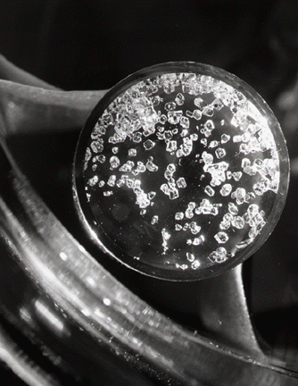
In contrast, A is a very stable, non toxic gas, which has a density of 3.57 g/dm³ at 27°C and normal air pressure.
Also B is a gas at standard conditions. It reacts slowly with water producing phosphonic acid (P(OH)₃).
Compound C is somehow an exotic one. Up to 1962 the chemists believed, that there are no compounds of this kind. Additionally to the element X another, very rare element is found, the name of which derives from the ancient Greek word „ξένος“ (= strange). M (C) = 207 g/mol.
Also D is not an commonplace compound. The new element, which is bound to X in this case, does not only form this compound, but also others with X. D contains 70.4 mass percent of X. Crystals of C

3.9. What is element X?
X:

3.10. Give the formulae of A, B, C, and D. Show your calculations, if this is possible.
A: | B:
C: | D:
Calculation:

3.11.At first sight, A and C have very similar formulae. In fact, their three dimensional structures are quite different. Sketch the three dimensional structures of both molecules using the VSEPR-theory, and find for both structures the point groups.

At the end, let us turn to the field of thermo chemistry. There is a very similar compound (concerning the molecular formula) compared to B, mono phosphane PH₃. It is for instance used as pesticide, especially to kill mice or insects in silos.
There are different methods to synthesize the substance. One of them, in analogy to the Haber-Bosch-process, starts from the elements white phosphorous (P₄) and hyddrogen.

3.12. Write down a balanced equation for this synthesis.

The reaction enthalpy of the process at 298 K (= standard formation enthalpy of phosphane) cannot be measured directly. But it is possible to measure the following reaction enthalpies at 25° C:
(a) P₄ + 5 O₂ → P₄O₁₀ $∆_{R}H_{298}^{O}=-2984 kJ$
(b) P₄O₁₀ + 6 H₂O → 4 H₃PO₄ $∆_{R}H_{298}^{O}=-415 kJ$
(c) 2 H₂ + O₂ → 2 H₂O $∆_{R}H_{298}^{O}=-572 kJ$
(d) PH₃ + 2 O₂ → H₃PO₄ $∆_{R}H_{298}^{O}=-1280 kJ$

3.13.Calculate the standard reaction enthalpy of process 3.12., and consequently the standard formation enthalpy of phosphane at 298 K.
$$∆_{B}H_{298}^{O}=$$
calculation:

At 298 K the synthesis of phosphane is so slow, that it is necessary to heat the system. This is done, whereby the system is heated up slightly above the boiling point of white phosphorous, namely to 300°C
(BP = 280°C). Use the following thermo dynamical data to solve the calculations in question:

 | $∆_{B}H_{298}^{O}$ (kJ/mol) | $S_{298}^{O}$ (J/mol·K) | C_{P}(J/mol·K)
P₄ (g) | 59 | 280 | 21
H₂ | 0 | 131 | 29
PH₃ | ? | 210 | 37

3.14. Calculate the equilibrium constant of the phosphane synthesis at 300°C.
K =
Calculation:

Task 4 17points

Nitrogen-Heterocycles

- Cimetidin, an antagonist for histamine receptors

It is well known that histamine binds specifically to receptors in the stomach, and thus starts the production of stomach acid. In many cases, an over production of stomach acid leads to gastric ulcer. Therefore the scientists from the company Smith Kline Beecham in the 1960ies started to look for an antagonist who binds to the same receptors, but do not stimulate the production of gastric acid. The common antihistamines which for instance act against hay fever, do not act against surplus production of gastric acid.
They started to “construct” a histamine receptor antagonist by “drug-design“. One example is cimetidine, one of the rare drugs which achieved annual sales of over one billion Dollars, and which saved pain and surgery for a lot of people.
Cimetidine contains sulfur and at the end a rest similar to guanidine, additionally to the histamine building block. [guanidine: H₂N-(C=NH)-NH₂]

The synthesis steps of cimetidine are shown in the following scheme:

or

Additionally, you have the following information at hand:
- B is generated from a compound F + H₂S. F shows 2 signals in a ¹H-NMR-spectrum with the intensities 1 and 4 (0,88 ppm and 1,36 ppm respectively; the signal at 1,36 ppm shows an untypical chemical shift).
- PbNCN is an ionic compound.

4.1. Draw the constitutional formulae of A, B, D, E, and F.
A | B |  | F
D |  | E

4.2. Which type of reaction is meant by the conversion from C to E, and from E to cimetidine (Look at the –CN-group!)

4.3. Draw the mechanism of the reaction C→E. Use for C R-NH₂, and arrows to show the positions of the respective attacks.

B: Ketorolac, an inflammation inhibitor

Ketorolac is an active substance from the group of non-stereoidal inflammation inhibitors with pain relieving and antipyretic properties. Different ways of synthesis for this bicyclic compound may be found in literature. One of these reaction schemes is shown:

carboxylic acid

- The reagent γ-butyrolacton, here used in the reaction benzoylpyrrol → U, serves as alkylation reagent to the pyrrol-nitrogen.
- The reaction X →Y is the closing of a ring.

4.4. Draw the structural formulae of U, V, X, and Y.
U | V
X | Y

4.5. What is the mechanism of the reaction X →Y? Think about AIBN.

Ketorolac appears as racemic mixture, whereby only the (S)-enantiomere has a medical effect.

4.6. Draw the structure of the (S)-enantiomere of ketorolac.
C. Norflurazon and Diclomezin, two herbicides belonging to the pyridazinon-type

Pyridazinone derives from the 6-ring-heterocycle pyridazine. The herbicides show a significance as plant protectant, especially in growing barley and cotton. They act by inhibiting photo synthesis and by decreasing the carotinoid-biosynthesis.
This task is about the synthesis of norflurazon and diclomezin.

One possible synthesis of norflurazon is described here:

a phenyl hydrazine

mucochloro axcid

4.7. Draw the structural formulae of G, H, and J.
G | H | J

4.8. Write down the formula of the reaction product of a carboxylic acid RCOOH with hydrazine. How do you call this class of substances?
formula: | name:
4.9. Write down the formula of the reaction product of an aldehyde RCHO with hydrazine.
How do you call this class of substances?
formula: | name:

4.10. Allocate the two N-atoms in compound I to the classes of compounds from above.

In reaction H →I, mucochloro acid is involved. Some sub-tasks for this issue:

4.11. Draw the possible stereo isomers of mucochloro acid.

Mucochloro acid is generated from furfural (= furane-2-carbaldehyde) with chlorine in aqueous solution. Thereby, one molecule CO₂ per molecule fufural is set free.

4.12. Write down a balanced equation for this reaction.

4.13. Mucochloro acid may also occur in a tautomeric cyclic form K.
Draw the structural formulae of K.

The mass spectrum of mucochloro acid shows three signals with highest m/e-values at 124 m/e, 126 m/e, and 128 m/e with the intensity proportion 9:6:1. The base peak (highest intensity) is found at
44 m/e.

4.14. Write down the molecular formula for the particle which causes the peak at 126 m/e.
Diclomezin is a further representative of the pyridazino herbicides. The synthesis is shown in the following. L is a cyclic compound with only one signal in a ¹H-NMR-spectrum.

4.15. Draw the structural formulae of L, M, N, and O.
L | M
N | O

