39th Austrian Chemistry Olympiad

National Competition

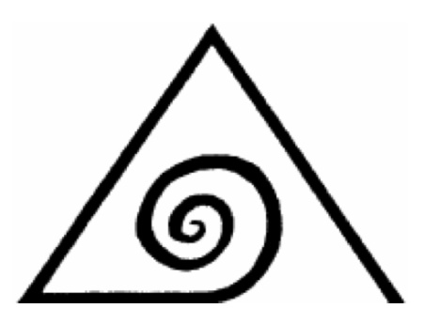

Solutions
with gradings

Task 1 54 bp ≙ 18 rp

From alchemy and modern chemistry

A. Aqua fortis

1.1. Write the formulae of the substances A-M as well as of copper vitriol, norges salpeter and pearl ash into the boxes in the reaction scheme
F: 2bp others each 1bp

1.2. Give a balanced equation for the following process: H → K + L + I
3 HNO₂ → HNO₃ + H₂O + 2 NO 1 bp

1.3. Draw a Lewis-structure for (a) as well as two mesomeric formulae for (b).

3 bp

1.4. Which of the two structures (a) or (b) is the one in the liquid C? (b)
1 bp

1.5. Draw a Lewis-structure of this anion.
1 bp
What will be the geometric shape according to VSEPR? (cross the circle)
O trigonal planar X bent O tetrahedral O linear 1 bp

1.6. Give the ionic formula of the cation of C : NO⁺ 1 bp
1.7. Complete the MO-scheme of this cation.
Hint: Following increasing energy, the symmetry of the MOs is: σ – σ* – π π – σ – π *π* – σ*
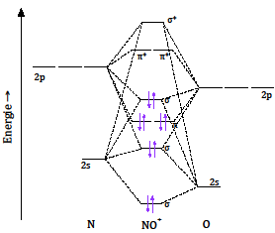 3 bp

2s
σ
π
π
σ*
π*
π*

The cation is X diamagnetic O paramagnetic? (cross the circle) 1bp

1.8. Calculate the theoretical yield von K using pounds as unit.
The stoichiometric proportion of sulphate and KNO₃ to KO₃NOSO, and from that to HNO₃ equals 1:1; the limiting substance is vitriol ⇒ 1.38 pounds
2bp

1.9. Calculate the amounts of C, I and J in the equilibrium. How many % of the original compound C are present in this equilibrium?

$\frac{\left[M\right]}{{\left[J\right]}^{2}}=6.807$ $\left[J\right]=\sqrt{\frac{\left[M\right]}{6.807}}=0.2277 mol/L$

[C] = 1 - x [I] = x [J] = 0.2277 mol/L

$\frac{\left[I\right]·\left[J\right]}{\left[C\right]}=3.203$ $\frac{x·0.2277}{1-x}=3.203$

x = [I] = 0.9336 mol/L

[C] = 1 - x = 0.06637 mol/L

6.64% of substance C are still present.
10 bp

1.10. Give the nuclide X which is produced in this process (with N and Z).
${{}_{79}^{197}{Au }}^{}$ 1 bp

1.11. How many atoms of ¹⁹⁷Hg are produced in the period mentioned? Show by calculation.

500 g of Hg are 2.493 mol, from that we have 3.739·10⁻³ mol or 2.252·10²¹ atoms of ¹⁹⁶Hg,
which have a cross section of 6.935 cm²
neutrons: 10¹⁵ · 78.25·3600 = 2.817·10²⁰ n·cm⁻²
yield: 1.954·10²¹ atoms of ¹⁹⁷Hg
4 bp
1.12. How many g of X are produced after the complete decay of this amount?
1.954·10²¹ atoms of ¹⁹⁷Hg → same number of Au-atoms, corresponding to 3.245·10⁻³ mol,
which are 0.639 g ¹⁹⁷Au
1 bp

C. What alchemists did not know

1.13. Give the formula of the elemental cell of chromite.
Fe₈Cr₁₆O₃₂ 1bp

1.14. Give formulae for both compounds.
Vessel I: [CrCl₂(OH₂)₄]Cl · 2 H₂O
Vessel II: [CrCl (OH₂)₅]Cl₂ · H₂O 1bp

1.15. Calculate for both masses the volume of silver nitrate solution, which is used for titration in the given procedures. Show the calculation for one vessel:
Sample from vessel I: 15.7 mL Sample from vessel II: 27.4 mL

2.092 g [CrCl₂(OH₂)₄]Cl · 2 H₂O are 7.85 mmol, one Cl⁻ free to react with Ag⁺,
therefore consumption for 10.00 mL 0.785 mmol Ag⁺ or 15.7 mL
1.827 g [CrCl(OH₂)₅]Cl₂ · H₂O are 6.86 mmol, two Cl⁻ free to react with Ag⁺,
therefore consumption for 10.00 mL 1.372 mmol Ag⁺ or 27.4 mL

2bp

1.16. Name the type of isomerism which connects the two compounds.
hydratation isomerism 1bp

1.17. Draw the orbital scheme of the d-orbitals for a high-spin and a low-spin complex of Fe(II) according to the ligand field theory.

2bp

Which of these two is valid for hexaammineiron(II)? X high-spin O low-spin 1bp

Task 2 21 bp ≙ 7 rp

Kinetics

A. Nucleophilic substitution

2.1. Try to find an expression for [R-OH₂⁺] using the first reaction:

$K_{EQ}=\frac{{[ROH}_{2}^{+}]}{\left[ROH\right]∙[H_{3}O^{+}]}$ ⇒ ${[ROH}_{2}^{+}]=K_{EQ}∙\left[ROH\right]∙[H_{3}O^{+}]$ 1.5 bp

2.2. Find an expression for the rate law of the formation of R-I applying the steady state theory for R⁺.

$\frac{{d[R}^{+}]}{dt}=0=k_{1}∙\left[{ROH}_{2}^{+}\right]-k_{2}∙\left[R^{+}\right]-k_{3}∙\left[R^{+}\right]∙[I^{-}]$ ⇒ $\left[R^{+}\right]=\frac{k_{1}∙{[ROH}_{2}^{+}]}{k_{2}+k_{3}∙[I^{-}]}$

$v=\frac{d[RI]}{dt}=k_{3}∙\left[R^{+}\right]∙\left[I^{-}\right]=\frac{k_{1}∙k_{3}∙{[ROH}_{2}^{+}]∙\left[I^{-}\right]}{k_{2}+k_{3}∙[I^{-}]}$

$v=\frac{k_{1}∙k_{3}∙K_{EQ}∙\left[H_{3}O^{+}\right]∙[ROH]∙\left[I^{-}\right]}{k_{2}+k_{3}∙[I^{-}]}$ 4.5 bp

2.3. Under which plausible assumptions will the rate law derived in 2.2. transform into the actual rate law? Thereby find an expression for k_{EXP}.

R⁺ reacts faster with I⁻ than with H₂O ⇒ $k_{2}≪k_{3}$

$v=\frac{k_{1}∙k_{3}∙K_{EQ}\left[H_{3}O^{+}\right]∙[ROH]∙\left[I^{-}\right]}{k_{3}∙[I^{-}]}$ = $k_{1}∙K_{EQ}∙\left[H_{3}O^{+}\right]∙[ROH]$

$k_{EXP}=k_{1}∙K_{EQ}$ 3 bp

B. Ester hydrolysis in basic solution

2.4. Write down a balanced reaction equation for this hydrolysis.
CH₃COOCH₂CH₃ + OH⁻ → CH₃COO⁻ + C₂H₅OH 1 bp

2.5. The conductivity decreases throughout the reaction. Why?
OH⁻ is replaced by Ac⁻; as the ion mobility of OH⁻ is bigger than the one of Ac⁻, the conductivity will decrease 2 bp

2.6. In our experiment, we have:
[A]₀ = [est]₀ = 0.040 mol·L⁻¹ und [B]₀ = [OH⁻]₀ = 0.020 mol·L⁻¹.
Using (1), (2) and the above data, derive the following rate law (3):

[B] ₀ = [OH⁻]₀ [B] _{t} = [OH⁻]_{t}
[A] ₀ = [est]₀ = 2[B] ₀ = 2[OH⁻]₀ [A] _{t} = 2[OH⁻]₀ – ([OH⁻]₀ - [OH⁻]_{t}) =[OH⁻]₀ + [OH⁻]_{t}

$\frac{1}{2{\left[OH\right]}_{0}-{\left[OH\right]}_{0}}∙ln\left[\frac{{\left[OH\right]}_{0∙}\left({\left[OH\right]}_{0}+{\left[OH\right]}_{t}\right)}{2{\left[OH\right]}_{0}∙{\left[OH\right]}_{t}}\right]=k∙t$

$ln\left[\frac{1}{2}∙\left(\frac{{\left[OH\right]}_{0}+{\left[OH\right]}_{t}}{{\left[OH\right]}_{t}}\right)\right]={\left[OH\right]}_{0}∙k∙t$

$ln\left[\frac{1}{2}∙\left(\frac{{\left[OH\right]}_{0}}{{\left[OH\right]}_{t}}+1\right)\right]={\left[OH\right]}_{0}∙k∙t$ with (1) we get:

$ln\left[\frac{1}{2}∙\left(\frac{κ_{0}-κ_{∞}}{κ_{t}-κ_{∞}}+1\right)\right]={\left[OH^{-}\right]}_{0}∙k∙t$ 4 bp

2.7. Calculate a mean value for k for both temperatures using (3).

$k=ln\left[\frac{1}{2}∙\left(\frac{κ_{0}-κ_{∞}}{κ_{t}-κ_{∞}}+1\right)\right]{\left({\left[OH^{-}\right]}_{0}∙t\right)}^{-1}$
Insertion of numbers from the table delivers for 52°C:
k₁ = 0.60 L∙mol⁻¹∙s⁻¹; k₂ = 0.57 L∙mol⁻¹∙s⁻¹; k₃ = 0.63 L∙mol⁻¹∙s⁻¹; k_{m} = 0.60 L∙mol⁻¹∙s⁻¹;
Insertion of numbers from the table delivers for 23°C:
k₁ = 0.10 L∙mol⁻¹∙s⁻¹; k₂ = 0.10 L∙mol⁻¹∙s⁻¹; k₃ = 0.10 L∙mol⁻¹∙s⁻¹; k_{m} = 0.10 L∙mol⁻¹∙s⁻¹;
3 bp

2.8. Calculate the activation energy for the ester hydrolysis.

$ln\frac{{k(T}_{2)}}{k(T_{1})} =\frac{E_{A}}{R}∙\left(\frac{1}{T_{1}}-\frac{1}{T_{2}}\right)$ ⇒ $E_{A}=R∙ln\frac{{k(T}_{2)}}{k(T_{1})}∙{\left(\frac{1}{T_{1}}-\frac{1}{T_{2}}\right)}^{-1}$

Using the numbers, we get E_{A} = 49.4 kJ 2 bp

Task 3 28 bp ≙ 8 rp
Something about lime stone

3.1. Give balanced equations for lime burning and lime slacking:

CaCO₃ → CaO + CO₂ 1 bp
CaO + H₂O → Ca(OH)₂ 1 bp

3.2. Calculate the mass of hydrated lime using the above data:

M(limestone) = 100 g/mol; M(Ca(OH)₂ ) = 74 g/mol;
1.00 t Kalk ⇒ 873 kg CaCO₃ ⇒ 8.73 kmol CaCO₃ ⇒ 8.73 kmol Ca(OH)₂ ⇒ 646.02 kg Ca(OH)₂
2×97% ⇒ 646.02×0.97² = 607.84
m(Ca(OH)₂) = 608 kg 2 bp

3.3. Which pressure have the walls of the vessel to withstand? Show by a calculation.

8.73 kmol CaCO₃ ⇒ 8.73 kmol CO₂ therefrom 97.0%: 8468.1 mol CO₂
Since T >T_{KR} all the CO₂ is gaseous ⇒ $p=\frac{n∙R∙T}{V}=\frac{8468.1∙8.314∙423}{50.0}=5.9562∙{10}^{5} Pa$
p = 5.96 bar 3 bp

3.4. What is the special behaviour of solid carbon dioxide, when it is heated at normal pressure?

CO₂ undergoes sublimation. 1 bp

3.5. Calculate the mean value for the evaporation enthalpy of carbon dioxide:

$Clausius-Clapeyron: ln\frac{p_{2}}{p_{1}}=\frac{∆H_{V}}{R}∙\left(\frac{1}{T_{1}}-\frac{1}{T_{2}}\right)$ ⇒ $∆H_{V}=R∙ln\frac{p_{2}}{p_{1}}∙{\left(\frac{1}{T_{1}}-\frac{1}{T_{2}}\right)}^{-1}$
p₁ = 5.2 bar; p₂ = 73.8 bar; T₁ = 216.6 K; T₂ = 304.1 K;
insertion of these numbers leads to: $∆H_{V}$ = 16.6 kJ·mol⁻¹ 3 bp

3.6. Which mass of CO₂ may be produced as a maximum? Show by calculation.

10.0 g marble ⇒ 0.10 mol;
20.0 mL HCl-solution ⇒ 21.5 g HCl-solution ⇒ 3.3325 g HCl ⇒ 0.091427 mol HCl
HCl is the limiting substance:
n (CO₂) = 0.091427/2 mol ⇒ m (CO₂) = 2.01 g 2.5 bp

3.7. Give a balanced equation for weathering of limestone:

CaCO₃ + H₂O + CO₂ → Ca(HCO₃)₂ 1.5 bp

3.8. Sketch the structure of CO₃ ²⁻. Name the symmetry elements of this particle.

C₃, 3×C₂, 3×σ_{V}, σ_{h} 3 bp

3.9. Calculate the vapour pressure of CO₂, which will be established theoretically above pure CaCO₃ at 25°C. Will lime stone decompose at 25°C?
p (CO₂) = K_{P} =$e^{-\frac{∆_{r}G^{O} }{RT}}$ $∆_{r}G^{O}=∆_{r}H^{O}-T∙∆_{r}S^{O}$

$∆_{r}H^{O}=-394-635+1207=178 kJ$
$∆_{r}S^{O}=214+39.8-92.9=160.9 J∙K^{-1}$
$∆_{r}G^{O}=178-298∙0.1609=130.05 kJ$ ⇒ p (CO₂) = $e^{-\frac{130050 }{8.314∙298}}=1.60∙{10}^{-23}$

p (CO₂) =$1.60∙{10}^{-23} bar$

p (CO₂)_{Luft} = 1.013$∙\frac{380}{{10}^{6}}=3.85∙{10}^{-4} bar$ > p (CO₂) ⇒ NO! 4.5 bp

3.10. At which temperature will CaCO₃ start to decompose in air? Assume that the caloric data do not depend on temperature.

p (CO₂) = K_{P} = p (CO₂)_{air} =$3.85∙{10}^{-4} bar$

$-R∙T∙ln$ p (CO₂)_{air} = $∆_{r}H^{O}-T∙∆_{r}S^{O}$

$T=\frac{∆_{r}H^{O}}{∆_{r}S^{O}- R∙T∙ln p ({CO}_{2})air}$ =$\frac{178000}{160.9-8.314∙ln⁡(3.85∙{10}^{-4})}$

T = 787 K 3.5 bp

3.11. At which temperature will the equilibrium of the calcium carbonate decomposition shift from left to right, using the same assumptions like in 3.10.?

K_{P} = 1 ⇒ $∆_{r}G^{O}=0=178000-T∙160.9$

T = 1.11·10³ K 2 bp

Task 4 36 bp ≙ 12 rp
Selenium – A rare trace element

4.1. Calculate the standard potential for the conversion of selenate to H₂Se, the respective biochemical standard potential at pH=7, as well as the free standard enthalpy, also at pH=7.

$∆E°=\frac{2·1.15+4·0.74+2·\left(-0.11\right)}{8}=0.63 V$

$∆E°´=0.63-\frac{8.314·298}{8·96485}·\ln\left(\frac{1}{{\left({10}^{-7}\right)}^{10}}\right)=0.11 V$

$∆G°´=-8·96485·0.11=-86.9 kJ/mol$ 6 bp

4.2. Draw the configuration formula of this anion and show your way of calculation.

assumption: only one Se-atom in compound X

$M=78.96·\frac{100}{49.68}=158.94 g/mol$

$M_{residue}=158.94-78.96=79.98 g/mol$

Possible elements: P, O, H configuration formula:
only possibility: HSePO₃²⁻

6 bp

4.3. Calculate the degree of dissociation of both groups at pH=7.

R-Se-H + H₂O ⇌ R-Se⁻ + H₃O⁺

$K_{a}=\frac{\left[R-Se^{-}\right]·\left[H_{3}O^{+}\right]}{\left[R-Se-H\right]}$

${10}^{-5.2}=\frac{α·{10}^{-7}}{1-α}$

$α=\frac{{10}^{-5.2}}{{10}^{-7}+{10}^{-5.2}}=0.984$ Degree of dissociation for R-Se-H : 98.4%.

$α=\frac{{10}^{-8.5}}{{10}^{-7}+{10}^{-8.5}}=0.031$ Degree of dissociation for R-S-H: 3.1%.

6 bp

4.4. Cross the correct answer(s):

X It is R-seleno cysteine

□ It is S-seleno cysteine

□ It is D-seleno cysteine

X It is L-seleno cysteine

4.5. In the below given tRNA-Struktures complete the respective missing amino acid (structure) at the right place!

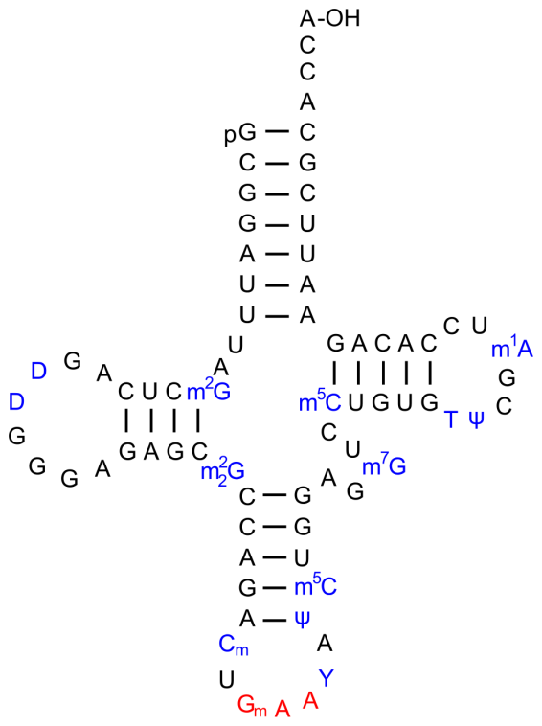
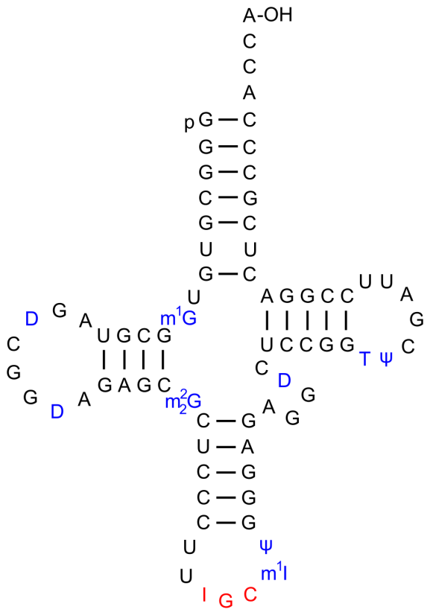 6 bp

4.6. Write down the short version for the overall reaction of hydrogen peroxide!

H₂O₂ + NADP·H + H⁺ ⇌2 H₂O + NADP⁺ 3 bp

4.7. Calculate ΔE°´, ΔG°´ as well as K´ for this reaction.

ΔE°´= 1.349 V + 0.315 V = 1.664 V

ΔG°´ = -z·F·ΔE°´ = -2·96485·1.664 = -321.1 kJ

$K´=e^{\frac{∆G°´}{-R·T}}=1.93·{10}^{56}$ 4 bp

4.8. Draw the stereochemically correct structure of glutathione.

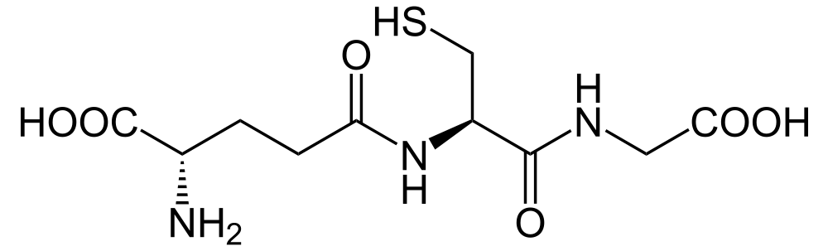

5 bp

Task 5 52 bp ≙ 15 rp

Cyclobutane derivatives in natural products

- Stereochemistry

5.1. Draw the constitutional formula of the hydrolysis product.

2 bp

5.2. Give the IUPAC-name of the hydrolysis product.

4-oxopent-2-enoic acid 1 bp

5.3. Draw the configuration formula of the so formed anemonin and add the respective stereo descriptor(s) to the stereogenic centre(s).

6 bp

5.4. Draw the configuration formula of the tetraol. 2 bp

B. Strukturaufklärung

5.5. Which conclusions concerning the carbon frame do you draw from the given information?
The structure contains two double bonds.
The structure contains additionally two rings. 2 bp

5.6. Draw the two possible configuration formulae of caryophyllene.

5 bp

C. Synthesis

5.7. Draw configuration formulae of the compounds B to I into the respective boxes.
B 2 bp | C 1 bp | D 3 bp
E 2 bp | F 2 bp | G 2 bp
H 2 bp | I 2 bp

5.8. What is the function of THP in organic synthesis technique?

It is a protection group for OH. 1 bp

5.9. Draw a mechanism for the reaction C → D. 3 bp

5.10. Attach the proper stereo descriptors to the stereogenic centres of (+)-grandisol. | 5.11. Indicate the correct statement(s) using “x”. 2 bp
3 bp | Pure (+)-grandisol is produced.
 | Optically inactive material is produced. | X
 | A racemic mixture is produced. | X
 | A mixture of diastereomeres is produced.

5.12. Draw the structures of the compounds K and L.
K 2 bp | L 1bp

5.13. To which type of reaction belongs the formation of K?

[2+2]-cycloaddition, photo dimerisation; connection of the rings always cis. 1 bp

5.14. In the formation of M: Why is the methyl group attacking nearly solely from above? 1 bp

The attack comes from above, because the space below is blocked by the cyclobutane ring.

5.15. Draw the structure of the intermediate, which emerges from the reaction of M with O₃ and subsequent reductive reworking. How will it react after that with periodate to produce N?

4 bp

