39th Austrian Chemistry Olympiad

National Competition

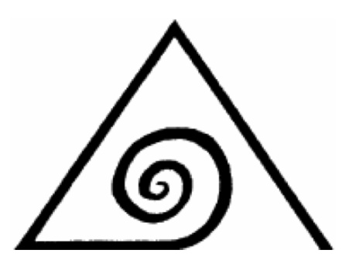

Name:........................................

Theoretical part – June 13th, 2013

Problem 1: ....../......../18
Problem 2: ....../......../7
Problem 3: ....../......../8
Problem 4: ....../......../12
Problem 5: ....../......../15

Total: .........../60

Hints
- You have 5 hours time to complete the solutions of the competition tasks.
- You may only use this paper, draft paper a periodic table of elements, a table with the genetic code and another table with the structures of amino acids occurring in proteins, a non programmable calculator, and a blue or black biro, nothing else.
- Write your answers in the boxes provided for them. Only these answers will be marked. If you don’t have enough space, then you may write on the back of the pages with the remark “belongs to part x.xx“, whereby x.xx means the part of the task in italics. You may take the PTE and the draft paper with you after the competition.

Constants and Data

R = 8.314 J/mol.K standard conditions: 25°C, 1 bar
N_{A} = 6.022‧10²³ mol⁻¹ normal conditions: 0°C, 1.013 bar
F = 96485 A.s/mol 1 ppm = 1 in 10⁶
273 K = 0°C

Some formulae

amount of substance | $n=\frac{m}{M}$
molar concentration | $c=\frac{n}{V}$
mass density | $ρ=\frac{m}{V}$
equation of ideal gases | $p∙V=n∙R∙T$
change of state variables (functions) | $$∆X=X_{FINAL}-X_{INITIAL}$$
free standard reaction enthalpy | $$∆G^{O}=∆H^{O}-T∙∆S^{O}$$
free standard reaction enthalpy and equilibrium | $$∆G^{O}=-R∙T∙lnK$$
free standard reaction enthalpy and redox pot. | $$∆G^{O}=-z∙F∙∆E^{O}$$
free reaction enthalpy | $∆G=∆G^{O}-R∙T∙lnQ=R∙T∙ln\frac{Q}{K}$
Clausius-Clapeyron-equation | $ln\frac{p_{2}}{P_{1}}=\frac{∆H_{U}}{R}\left(\frac{1}{T_{1}}-\frac{1}{T_{2}}\right)$
Equilibrium constant (Y=concentration variable) | $K=\frac{Y_{C}^{u}∙Y_{D}^{v}}{Y_{A}^{x}∙Y_{B}^{z}}$
acid constant | $K_{A}=\frac{\left[H_{3}O^{+}\right]∙[A^{-}]}{[HA]}$
Arrhenius equation | $k=A∙e^{-\frac{E_{A}}{RT}}$
Nernst equation | $E=E^{O}+\frac{R∙T}{z∙F}ln\frac{[OX]}{[RED]}$
Nernst equation | $∆E={∆E}^{O}-\frac{R∙T}{z∙F}lnQ$
Luther‘s formula | $∆E^{O}=\frac{\sum_{i}{z_{i}∙∆E_{i}^{O}}}{\sum_{i}{z_{i}}}$

Task 1 18 points

From alchemy and modern chemistry

A. Aqua fortis

Among all the recipes of alchemists you will find the formulation of aqua fortis from vitriol and salpeter, which was also practiced in Oberstockstall in Lower Austria. Using methods of modern chemistry, the complex correlations and part reactions of this process could be clarified. Thereby the following „alchemistic flow sheet“ from today’s knowledge could be established:

Some additional informations concerning the substances

- D is an element.
- E is a binary compound from two chalcogenes. A glass alembic (1675 mL of volume) contains 3.047 g E at p =1.013 bar and 156°C.
- C is a binary compound consisting of 63.15% of element D. Furthermore, C is the anhydride of H.
- Aqua fortis (K) dissolves metals (e.g. brass) generating brown fume. This gas is identical with substance, J, whereas I is colourless. The latter reacts with element D quickly in a redox reaction producing J.
- J dimerises to give M, the reaction leading to an interesting equilibrium which is dealt with later.
- A and the norges salpeter may be looked at as salts of aqua fortis. Pearl ash and B contain the same anion. By the way, B plays a central role in task 3.
- The water free copper vitriol is white, whereas the pentahydrate has a blue colour.
- The condensation of sulphuric acid, splitting off one equivalent of H₂O, generates the acid of which the anion is the same as in G.
- F is an very unusual compound made from four elements. The cation is an alkali metal and has the same electron configuration as argon. It covers 23.67% by mass of F and has its origin in A. Element D covers 48,43%.

1.1. Write the formulae of the substances A-M as well as of copper vitriol, norges salpeter and pearl ash into the boxes in the reaction scheme

1.2. Give a balanced equation for the following process: H → K + L + I

Compound C appears as deep blue liquid at very low temperatures. It is also soluble in organic solvents producing blue solutions. Anyway, two isomeric structures exist:

1.3. Draw a Lewis-structure for (a) as well as two mesomeric formulae for (b).

Both structures absorb light, (a) at λ = 380 nm, (b) at λ = 720 nm.

1.4. Which of the two structures (a) or (b) is the one in the liquid C?

At temperatures <-100°C also an ionic form of C exists, they anion of it being the conjugate base of H.

1.5. Draw a Lewis-structure of this anion.

What will be the geometric shape according to VSEPR? (cross the circle)
O trigonal planar O bent O tetrahedral O linear

1.6. Give the ionic formula of the cation of C :

1.7. Complete the MO-scheme of this cation.
Hint: Following increasing energy, the symmetry of the MOs is: σ – σ* – π π – σ – π *π* – σ*

E

2p
2p

2s

2s

The cation is O diamagnetic O paramagnetic? (cross the circle)

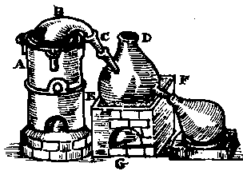
The original of a formulation (in German):

„Nimm vier pfund reinen Salpeter/vnd vierthalb pfund calcionierten Victrils/..../reib die beide gantz klein vnd thu sie in ein beschlagenen glaßkolben/ kere mit einem hasen fuß an ein steblein gebunden den zeug im kolben am halß ab/damit das wasser rein herübergehe vnd nicht vrsachen hab vberzusteigen.“
Lies: „vierthalb“ = „drei und ein halbes“ alchemistic distillation apparatus

It is not possible to translate that into English because the words in ancient German do not exist anymore in today’s German. The highlighted text contains the valuable information:

Take four pond of pure salpeter/and three and a half pound calcinated victril/....

Assume that the pure salpeter is substance A, calcinated victril is water free copper sulphate. One pound is according to today’s definition 453.592370 g. The conversion of C to K is complete assuming an ideal case.

1.8. Calculate the theoretical yield von K using pounds as unit.

Equilibria in the labs of alchemists:

Compound C is a gas at room temperature, but not stable and decomposes to yield the gases I and J:

C_{(g)} ⇌ I_{(g)} + J_{(g)} K_{c} = 3.203

Compound J dimerises to give gas M:
2 J_{(g)} ⇌ M_{(g)} K_{c} = 6.807

1.0000 mol of compound C were evaporated in a flask with a volume of 1.0000 L at room temperature. After establishing the equilibrium, 0.3530 mol of substance M were generated.

1.9. Calculate the amounts of C, I and J in the equilibrium. How many % of the original compound C are present in this equilibrium?

B. Transmutation

To produce the element X from othr elements by transmutation was a dream for many alchemists. Today, this transmutation is possible, although we have to use other than alchemistic methods:

${{}_{}^{196}{Hg \left(n,γ\right)}}^{197}Hg \underset{→}{(electron capture)}$X

1.10. Give the nuclide X which is produced in this process (with N and Z).

The reaction was executed in a reactor with high neutron flux (${10}^{15} neutrons·cm^{-2}s^{-1} )$, whereby 500 g of natural mercury were irradiated throughout a period of 78.25 hours. Natural mercury contains 0.15% of atoms ¹⁹⁶Hg. ¹⁹⁶Hg has a capture cross section of $3080⋅{10}^{-24}cm^{2}$for neutrons. The capture cross section is a measure for the frequency of nuclear reactions, but may also be looked at as “area“of the target nuclide, which is hit by neutrons.
In the following calculations, us the mass numbers instead of the atomic masses.

1.11. How many atoms of ¹⁹⁷Hg are produced in the period mentioned? Show by calculation.

1.12 How many g of X are produced after the complete decay of this amount?

C. What alchemists did not know

Although chromium salts were already used in ancient China to preserve bronze swords, chromium was first attained as an element in 1798. Today, chromite is the only relevant chromium mineral. Chromite is about to be a so called spinel. In this often occurring structure type, oxide ions form a cubic dense packed lattice. 1/8 of all tetrahedron cavities are occupied by a bivalent metal (in case of chromite Fe²⁺). Half of the octahedron cavities are occupied by a trivalent metal (here Cr³⁺). The elmental cell of chromite carries 32 O²⁻ - ions, which are located in the corners and the centres of the faces of 8 octandes of a cube.

1.13. Give the formula of the elemental cell of chromite.

Two different vessels of a modern alchemist contain two different solid chromium complexes. The labels were mixed up through carelessness. To be sure which is which, both compounds were dissolved, using the given masses. The solutions were filled up to 100.0 mL.

Vessel I, labelled „tetraaquadichloridochromium(III)-chloride-dihydrate“, mass: 2.092 g
Vessel II, labelled „pentaaquachloridochromium(III)- chloride-hydrate“, mass 1.827 g

10.00 mL are taken out from each vessel and titrated with 0.050 M AgNO₃.

1.14. Give formulae for both compounds.
Vessel I:
Vessel II:

1.15. Calculate for both masses the volume of silver nitrate solution, which is used for titration in the given procedures. Show the calculation for one vessel:
Sample from vessel I: Sample from vessel II:

1.16. Name the type of isomerism which connects the two compounds.

Additionally, the Fe²⁺-ions which are present in chromite, also form complexes, in aqueous solution initially hexaaquairon(II). The latter is converted into a hexaammineiron(II)-complex by addition of concentrated ammonia. The magnetic properties of this octahedral complex indicate 4 unpaired electrons.

1.17. Draw the orbital scheme of the d-orbitals for a high-spin and a low-spin complex of Fe(II) according to the ligand field theory.

Which of these two is valid for hexaamminiron(II)? O high-spin O low-spin (cross the circle)

Task 2 7 points
Kinetics

A. Nucleophilic substitution

In aqueous acidic solution ([H₂O] is no variable), t-butanol is converted to t-butyl iodide using iodide ions:

The reaction is of 1st order related to t-butanol and H₃O⁺, the concentration of iodide ions does not influence the reaction rate. In order to clarify this curious result, we start from the following possible mechanism:

2.1. Try to find an expression for [R-OH₂⁺] using the first reaction:

2.2. Find an expression for the rate law of the formation of R-I applying the steady state theory for R⁺.

The actual rate law runs as follows: $v=k_{EXP}∙\left[R-OH\right]∙[H_{3}O^{+}]$

2.3. Under which plausible assumptions will the rate law derived in 2.2. transform into the actual rate law? Thereby find an expression for k_{EXP}.

B. Ester hydrolysis in basic solution

The hydrolysis of acetic acid ethyl ester with OH⁻ is a second order reaction. It can be investigated kinetically by measuring the specific conductivity.

2.4. Write down a balanced reaction equation for this hydrolysis.

2.5. The conductivity decreases throughout the reaction. Why?

The experiment was performed using a mixture of NaOH and a surplus of acetic acid ethyl ester. In this case the following mathematical expression connecting conductivity and [OH⁻] comes into place:
$\frac{{\left[OH^{-}\right]}_{0}}{{\left[OH^{-}\right]}_{t}}=\frac{κ_{0}-κ_{∞}}{κ_{t}-κ_{∞}}$ (1)

Thereby: ${\left[OH^{-}\right]}_{0}$……….initial hydroxide concentration
${\left[OH^{-}\right]}_{t}$………. hydroxide concentration at any time
$κ_{0}$………..……..initial specific conductivity
$κ_{t}$…………..…... specific conductivity at any time
$κ_{∞}$……….....…..final specific conductivity

The integrated rate law for second order reactions, in which the initial concentrations are different, is:

$\frac{1}{{\left[A\right]}_{0}-{\left[B\right]}_{0}}∙ln\frac{{\left[B\right]}_{0}∙{\left[A\right]}_{t}}{{\left[A\right]}_{0}∙{\left[B\right]}_{t}}=k∙t$ (2)

2.6. In our experiment, we have:
[A]₀ = [ester]₀ = 0.040 mol·L⁻¹ und [B]₀ = [OH⁻]₀ = 0.020 mol·L⁻¹.
Using (1), (2) and the above data, derive the following rate law (3):

$ln\left[\frac{1}{2}∙\left(\frac{κ_{0}-κ_{∞}}{κ_{t}-κ_{∞}}+1\right)\right]={\left[OH^{-}\right]}_{0}∙k∙t$ (3)

The following data for the conductivities were obtained:

1st experiment: T = 52°C |  | 2nd experiment: T = 23°C
t (s) | κ (mS/cm) | t (s) | κ (mS/cm)
0 | 3.27 | 0 | 3.79
120 | 1.67 | 120 | 2.91
240 | 1.48 | 240 | 2.39
360 | 1.43 | 360 | 2.08
∞ | 1.42 | ∞ | 1.28

2.7. Calculate a mean value for k for both temperatures using (3).

2.8. Calculate the activation energy for the ester hydrolysis.

Task 3 8 points
Something about lime stone

Chemically, lime stone is calcium carbonate. It is found in nature in various forms as mineral or in rocks forming mountains. Artists have manufactured the most wonderful sculptures from marble, common lime stone is an important starting material in building industry. Iceland spar as a rare example shows the phenomenon of double refraction (birefringence).
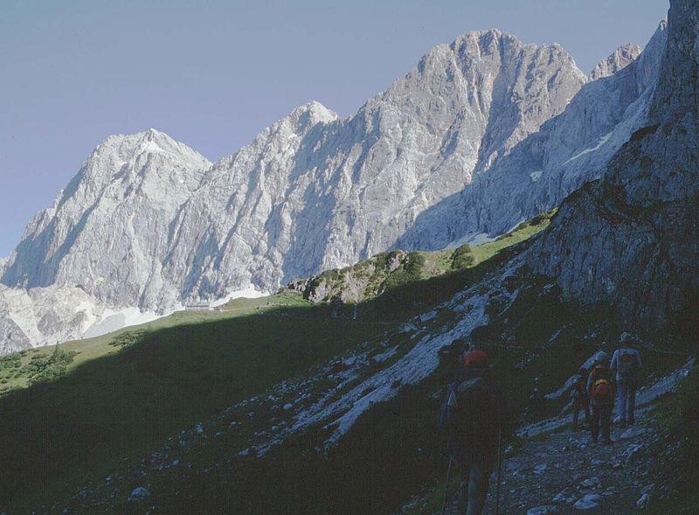
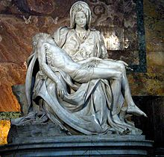
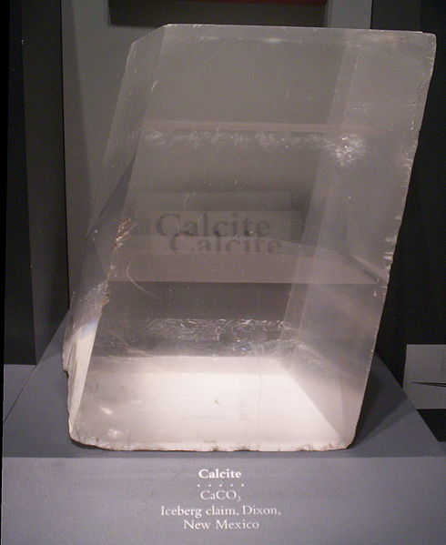

Iceland spar marble-pieta by Michelangelo lime stone rocks:
the south wall of the Dachstein

From 1.00 t of lime stone, containing 87.3% of calcium carbonate, hydrated lime is produced via burnt lime as intermediate (heating to 1000°C). Each of the two reactions has a yield of 97%.

3.1. Give balanced equations for lime burning and lime slacking:

3.2. Calculate the mass of hydrated lime using the above data:

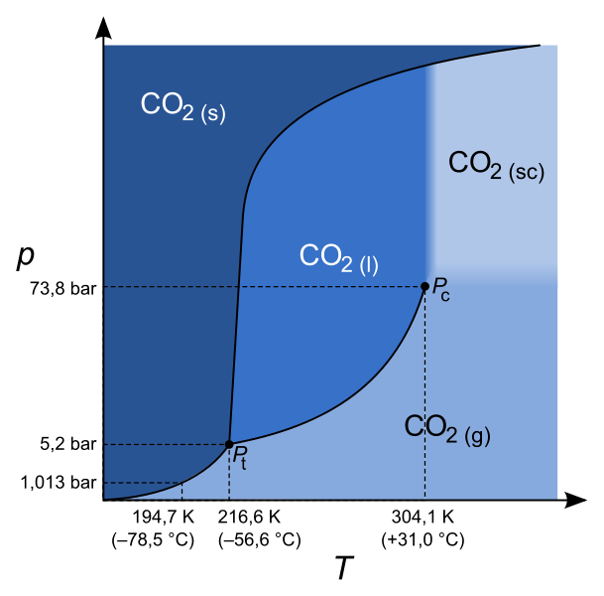

To accomplish the following calculations the shown phase diagram (axis are not scaled!) is very useful.

Carbon dioxide which is produced in the above lime burning is filled into a vessel with V = 50.0 m³. It is cooled down to 150°C.

3.3. Which pressure have the walls of the vessel to withstand? Show by a calculation.

3.4. What is the special behaviour of solid carbon dioxide, when it is heated at normal pressure?

3.5. Calculate the mean value for the evaporation enthalpy of carbon dioxide:

In a lab, carbon dioxide may be simply produced from pieces of marble and hydrochloric acid, because carbonate reacts as a base. 10.0 g of marble are mixed with 20.0 mL a 15.5%(w/w) hydrochloric acid (density ρ = 1.075 g·cm⁻³).

3.6. Which mass of CO₂ may be produced as a maximum? Show by calculation.

Weathering of lime stone, which leads to clefts, dolines and caves, is also based on the reaction of carbonates with an “acid“. Take the composition of air into account.

3.7. Give a balanced equation for weathering of limestone:

All the C-O-distances in carbonate ions have a length of 0.130 nm.

3.8. Sketch the structure of CO₃ ²⁻. Name the symmetry elements of this particle.

Let us go back to lime burning. To find answers to the following questions and for the respective calculations you will find caloric data in the table.
Additionally: p (air) = 1.013 bar; CO₂ content in air: 380 ppm

 | CaCO₃ (s) | CaO (s) | CO₂ (g)
Δ_{f}H^{O}₂₉₈ (kJ·mol⁻¹) | -1207 | -635 | -394
S ^{O}₂₉₈ (J·mol⁻¹·K⁻¹) | 92.9 | 39.8 | 214

3.9. Calculate the vapour pressure of CO₂, which will be established theoretically above pure CaCO₃ at 25°C. Will lime stone decompose at 25°C?

3.10. At which temperature will CaCO₃ start to decompose in air? Assume that the caloric data do not depend on temperature.

3.11. At which temperature will the equilibrium of the calcium carbonate decomposition shift from left to right, using the same assumptions like in 3.10.?

Task 4 12 points
Selenium – A rare trace element

Selenium is a rare trace element, which nevertheless plays an important role in our body. Usually it is ingested as selenate SeO₄²⁻ or selenite SeO₃²⁻, and then converted to H₂Se in the organism.
The following Latimer-diagram with standard potentials is given:

$$SeO_{4}^{2-}\underset{→}{ 1,15 V }H_{2}SeO_{3}\underset{→}{ 0,74 V }Se\underset{→}{ -0,11 V }H_{2}Se$$

4.1. Calculate the standard potential for the conversion of selenate to H₂Se, the respective biochemical standard potential at pH=7, as well as the free standard enthalpy, also at pH=7.

In a next step, H₂Se using ATP reacts to the selenium compound X, which is necessary for the formation of selenium containing enzymes. X consists of four different elements, six atoms, has a charge of 2-, and a selenium fraction of 49.68 % (w/w).

4.2. Draw the configuration formula of this anion and show your way of calculation.

One of the most important functions in the human body selenium has in the amino acid seleno cysteine. There, a selenium atom replaces the sulphur atom of the amino acid cysteine. In some enzymes it is indispensable as active centre. There were investigations to find out why in special enzymes selenium cannot be replaced by the chemically similar sulphur. An important difference could be the different pK_{a}-values: in seleno cystein the Se-H-group shows a pK_{a}-value of 5.2, in cysteine the pK_{a}-value of the S-H-group amounts to 8.5.

4.3. Calculate the degree of dissociation of both groups at pH=7.

The amino acid seleno cysteine, occurring in nature, has the following configuration formula:

4.4. Cross the correct answer(s):

□ It is R-seleno cysteine

□ It is S-seleno cysteine

□ It is D-seleno cysteine

□ It is L-seleno cysteine

For the biosynthesis of seleno cysteine (Sec) in E. coli a special tRNA^{Sec} acts having the following structure:

Similar tRNA-molecules exist for all the amino acids. Thereby, I stands for inosine, a rare base, which can be paired with all the other bases. The index m stands for smaller modifications, which do not change anything in the possibilities for pairing. All the other non usual bases are not important in the given questions.
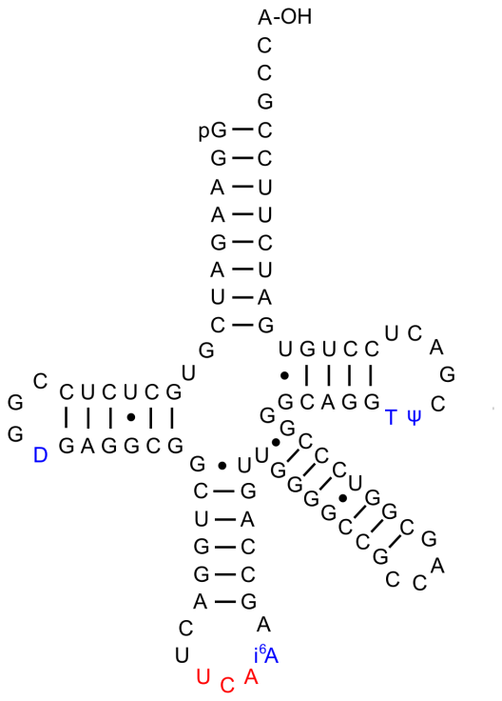
4.5. In the below given tRNA-structures complete the respective missing amino acid (structure) at the right place!

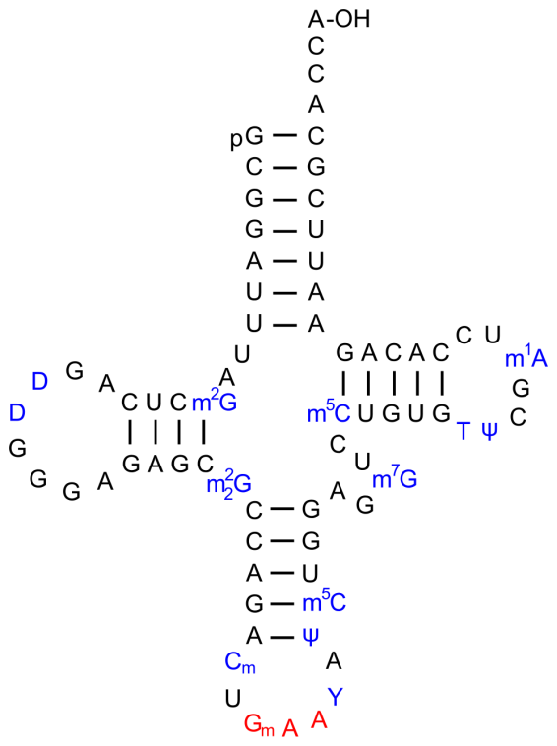
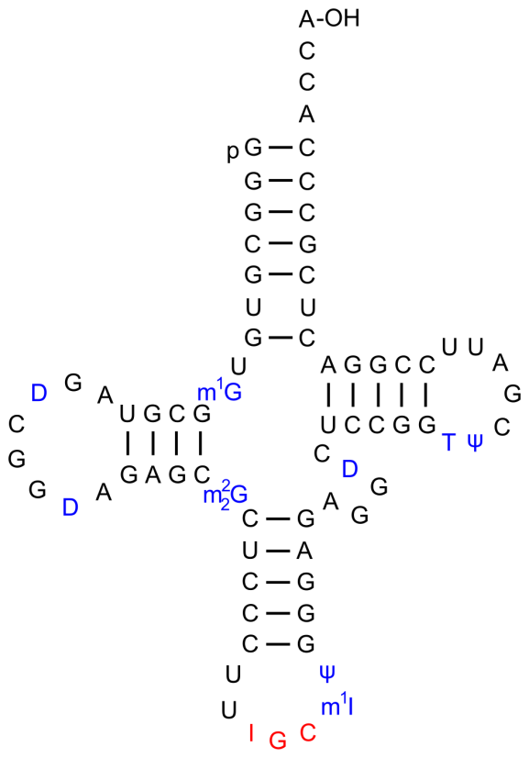

Glutathione-peroxidase (GPx) is an important enzyme, which also contains the amino acid seleno cysteine. The function of this enzyme is its antioxidative effect. Thereby GPx reacts with peroxides generated in the organism destroying them. The GPx-selenium acid (GPx-SeOH) which is formed in this reaction, continues to react with glutathione (G-SH), and the initial form of GPx is re-established.
As a model compound for this reaction, hydrogen peroxide is used, which is a representative for all peroxides.

You are given the biochemical standard potentials of the following reactions:

H₂O₂ + 2 H⁺ + 2 e⁻ ⇌ 2 H₂O E°´ = +1.349 V
G-S-S-G + 2H⁺ + 2 e⁻ ⇌ 2 G-SH E°´ = -0.240 V
NADP⁺ + 2 H⁺ + 2 e⁻ ⇌ NADP·H + H⁺ E°´ = -0.315 V
R-Se-Se-R + 2 H⁺ + 2 e⁻ ⇌ 2 R-Se-H E°´ = -0.488 V

The reaction follows the given scheme:

4.6. Write down the short version for the overall reaction of hydrogen peroxide!

4.7. Calculate ΔE°´, ΔG°´ as well as K´ for this reaction.

Glutathione is a tripeptide, consisting of the three amino acids glutamate, cysteine and glycine. Nearly all cells contain it in high concentrations, and it belongs to the most important as antioxidant acting substances in the body. At the same time it is a resource for cysteine. In fact, glutathione is not a true peptide, because the amide bonding between glutamate and cysteine is established via the γ-carboxylic group of glutamate, and not via the α-carboxylic group, as usual in true peptide bonding. Glycine is the C-terminal of the tripeptide.

4.8. Draw the stereochemically correct structure of glutathione.

Task 5 15 points
Cyclobutane derivatives in natural products

- Stereochemistry

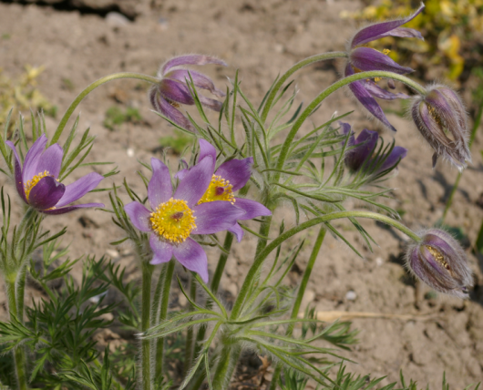
Anemonin is an alkaloid which is found in ranunculaceae. It is a conversion product of the toxic protoanemonin, which is liberated when injuring the plant. It causes itching and reddening in contact with the skin.

Ranunculaceae: pasqueflower

Protoanemonin undergoes mild hydrolysis. The ¹H-NMR-spectrum of the product after acidic reworking is given:
5.1. Draw the constitutional formula of the hydrolysis product.

5.2. Give the IUPAC-name of the hydrolysis product.

Anemonin is generated from protoanemonin slowly in the air or in contact with water. This dimerisation is started by light in the technical synthesis. The bonding happens in a way, so that the two O-atoms are in trans-position to each other.

5.3. Draw the configuration formula of the so formed anemonin and add the respective stereo descriptor(s) to the stereogenic centre(s).

In the catalytic hydrogenation of anemonin 2 equivalents of H₂ are added. Subsequent reduction with LiAlH₄ delivers a tetraol.

5.4. Draw the configuration formula of the tetraol.

B. Structure determination
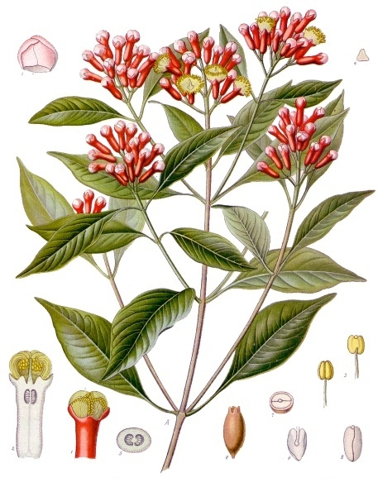
An unusual terpene with a cyclobutane framework is γ-caryophyllene, the main component of the aroma of cloves. The structure of this natural compound should be determined using the following information.
The sum formula is C₁₅H₂₄, in catalytic hydrogenation C₁₅H₂₈ is produced.

5.5. Which conclusions concerning the carbon frame do you draw from the given information?

Cloves

The following degradation reactions are executed:

5.6. Draw the two possible configuration formulae of caryophyllene.

C. Synthesis

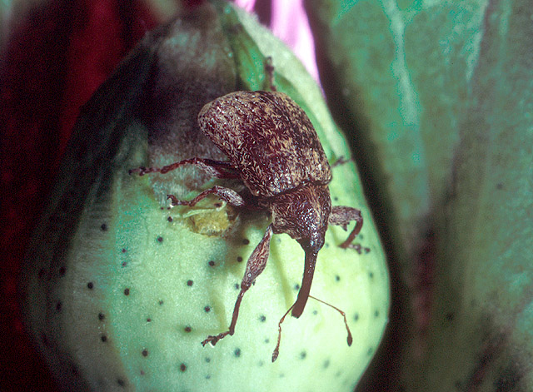
Grandisol, a derivate of cyclobutane also belongs to the class of terpenes. This substance was used to study some strategies for the synthesis of cyyclobutane derivatives. (+)-grandisol is the sexual pheromone of the male boll weevil. This beetle causes big damages in the American cotton harvest every year.

boll weevil

In the nineteen seventies a classical method of grandisol-synthesis was developed. It is shown in the following reaction scheme:

The following additional information is given:
- MCPBA stands for m-chloroperbenzoic acid
- DIBAL stands for diisobutylaluminiumhydride
abbreviation:

- Step C → D involves the ring formation.

5.7. Draw configuration formulae of the compounds B to I into the respective boxes.
B | C | D
E | F | G
H | I

5.8. What is the function of THP in organic synthesis technique?

5.9. Draw a mechanism for the reaction C → D.

5.10. Attach the proper stereo descriptors to the stereogenic centres of (+)-grandisol. | 5.11. Indicate the correct statement(s) using “x”.
 | Pure (+)-grandisol is produced.
 | Optically inactive material is produced.
 | A racemic mixture is produced.
 | A mixture of diastereomeres is produced.

Another way of synthesis of grandisol uses a different strategy to build the cyclobutane ring. The main steps of this alternative are shown in the following scheme:

5.12. Draw the structures of the compounds K and L.

5.13. To which type of reaction belongs the formation of K?

5.14. In the formation of M: Why is the methyl group attacking nearly solely from above?

5.15. Draw the structure of the intermediate, which emerges from the reaction of M with O₃ and subsequent reductive reworking. How will it react after that with periodate to produce N?

