39th Austrian Chemistry Olympiad

National Competition

Practical Part – June 15th, 2013

Solutions
with grading

Task 6 13 rp ≙ 48 bp

Qualitative Analysis

Write your analytical results into the table:

Sample | Cation | Anion
1 | Na⁺  2 bp | HSO₄⁻  3 bp
2 | K⁺  2 bp | PO₄³⁻  3 bp
3 | Cr³⁺  3 bp | NO₃⁻  4 bp
4 | Fe³⁺  3 bp | SO₄²⁻  4 bp
5 | K⁺  2 bp | SCN⁻  3 bp
6 | Cu²⁺  2 bp | Ac⁻  3 bp
7 | Al³⁺  4 bp | Cl⁻  3 bp
8 | Zn²⁺  4 bp | I⁻  3 bp

Task 7 14 rp ≙ 29 bp

Quantitative analysis and physical chemistry
conductivity of strong and weak electrolytes

Work to do

a) Determination of the acetic acid concentration

7.1 Exact concentration of acetic acid:
Chosen volume of acetic acid sample: e.g. 10.0 mL
titration volumen NaOH (mean value): e.g. 10.1 mL*
Calculation:

$c\left(HAc\right)=\frac{c(NaOH)∙V(NaOH)}{V(HAc)}=\frac{0.1∙10.1}{10}=0.101$ mol/L 1 bp

* V =V_{true} ≤±1% ⇒ 7 bp in between: bp = $7-\frac{7}{4}\left(\frac{\left|∆V\right|}{V_{true}}∙100-1\right)$
V =V_{true} >±5% ⇒ 0 bp

b) Measure of the specific conductivity of strong and weak electrolytes

7.2 Conductivity
potassium chloride solution (at least 4 solutions must be measured ⇒ 4 bp)
10 mL ad 100 mL | 20 mL ad 100 mL |  | 50 mL ad 100 mL |  | stock solution
c₁ = 0.0100 M | c₂ = 0.0200 M |  | c₃ = 0.0500 M |  | c₄ = 0.100 M
$\sqrt{c_{1}}$= 0.100 M^{0.5} | $\sqrt{c_{2}}$= 0.141 M^{0.5} |  | $\sqrt{c_{3}}$= 0.224 M^{0.5} |  | $\sqrt{c_{4}}$= 0.316 M^{0.5}
κ_{C1} = 1.44 mS∙cm⁻¹ | κ_{C2} =2.82 mS∙cm⁻¹ |  | κ_{C3} =6.67 mS∙cm⁻¹ |  | κ_{C4} =12.88 mS∙cm⁻¹
Λ_{c1} = 144.0 S∙cm²∙mol⁻¹ | Λ_{c2} = 141.0 S∙cm²∙mol⁻¹ |  | Λ_{c3} = 133.4 S∙cm²∙mol⁻¹ |  | Λ_{c4} = 128.8 S∙cm²∙mol⁻¹
acetic acid solution (at least 3 solutions must be measured ⇒ 3 bp)
10 mL ad 100 mL |  | 50 mL ad 100 mL |  | stock solution
c₁ = 0.0101 M |  | c₂ = 0.0505 M |  | c₃ = 0.101 M
κ_{C1} = 0.163 mS∙cm⁻¹ |  | κ_{C2} = 0.364 mS∙cm⁻¹ |  | κ_{C3} = 0.509 mS∙cm⁻¹
Λ_{c1} = 16.1 S∙cm²∙mol⁻¹ |  | Λ_{c2} = 7.21 S∙cm²∙mol⁻¹ |  | Λ_{c3} = 5.04 S∙cm²∙mol⁻¹

c) Graphic evaluation and calculation of data

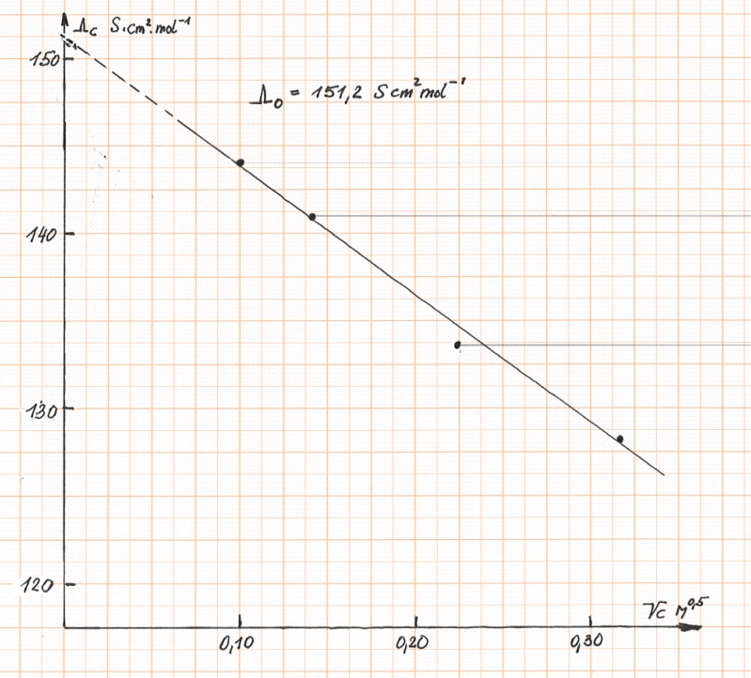
7.3 Potassium chloride solution: Draw a graph Λ_{c} vs. $\sqrt{c}$ using the cross section paper. Choose a suitable scale.
7.4 Determine graphically Λ₀ for potassium chloride and write the value into the drawing
Watch the units!

For each correct calculation of the $\sqrt{c}$-values: 0.25 bp
For each correct calculation of the Λ_{c}-values: 0.25 bp

Λ₀ = 146-156 S·cm²/mol: 3 bp
Λ₀ = 140-162 S·cm²/mol: 2 bp
Λ₀ = 135-167 S·cm²/mol: 1 bp

Graph: For correct notation of the axis 1 bp
For a reasonable scaling 1 bp
For neat drawing 1 bp

7.5 Calculate the degrees of protolysis for the different concentrations of the acetic acid solution using Λ₀(HAc) = 390.7 S·cm²∙mol⁻¹. Calculate also a mean value for the acid constant and the pK_{A}.

Calculation (one example):
For each correct calculation of the Λ_{c}-values: 0.25 bp
For each correct calculation of the α- values: 0.25 bp$α=\frac{5.04}{390.7}=0.0129$
For each correct calculation of the K_{A}-mean value: 1 bp ${ K}_{A}=\frac{{0.0129}^{2}}{1-0.0129}∙0.101=1.70∙{10}^{-5}$
For each correct calculation of the pK_{A}-values: 0.5 bp
K_{A} = 1.65∙10⁻⁵ - 1.85∙10⁻⁵: 3 bp K_{A} = 1.55∙10⁻⁵ - 1.95∙10⁻⁵: 2 bp K_{A} = 1.45∙10⁻⁵ – 2.05∙10⁻⁵: 1 bp

α(c₁) = 0.041 | α(c₂) = 0.018 |  | α(c₃) = 0.013
K_{A} = 1.80∙10⁻⁵ | K_{A} = 1.75∙10⁻⁵ |  | K_{A} = 1.70∙10⁻⁵
K_{A}(mean value) = 1.75∙10⁻⁵ |  | pK_{A} = 4.76

Task 8 23 bp ≙ 13 rp

8.1. Appearance of the product: orange crystals……2 bp
other appearances……0-1 bp

8.2. Calculate the theoretical yield: 1 bp

1 mol cyclohexanone (98 g) gives 1 mol product (171 g),
therefore 1.25 g starting material give 2.18 g of product

8.3. Calculate your yield in g and % of the theory:
No product: 0 bp
≥ 1.30 g: 10 bp, between 0 and 1.30 g:
+calculation of % 1 bp

8.4. melting point: for ⩾ 118°C: 3 bp ; for ⩾ 115°C: 2 bp ; for ⩾ 110°C: 1 bp ;

8.5. For start line, front line, marking of 2 spots: 4 bp
For every missing marking -1 bp

8.6. R_{f}-value of the intermediate: 0.35 1 bp

R_{f}-value of the final product: 0.42 1 bp

